Delhi Department of Trade and Taxes
Implementation of VAT

Submitted to
Centre for Civil Society

By
RAHUL GARG

Working Paper No 218
Summer Research Internship 2009

TABLE OF CONTENTS

Executive Summary …3

Methodology …5

Part A- Introduction
A.1) Overview of VAT …6
A.2) How does VAT work? …9
A.3) Delhi Department of Trade and Taxes …13
A.4) A Look at CAG reports …15
A.5) Internal Tax Collection Report …18
A.6) Brief Rules of VAT …21
A.7) Advantages, Disadvantage & Principles …23

Part B- The Issues
B.1) Launch of VAT …27
1.1) Registration …27
1.2) Education …28
B.2) Compliance …30
2.1) Forms, documentation, filing …30
2.2) Central forms …31
2.3 Payment of Taxes …33
2.4) Taxpayer- Tax authority interface …33

B.3) Penalties, Scrutiny and Appeals …35
3.1) Penalties …35
3.2) Scrutiny …37
3.3) Appeals …39

B.4) Departmental Issues …43
4.1) Manpower shortage …43
4.2) No dedicated Revenue Cadre …43
4.3) Functional vs. geographical classification …44
4.4) Voice of traders …45

B.5) Computerization …47
5.1) Online facilities for taxpayers …47
5.2) It infrastructure/ electronic database …47
5.3) Training of department staff …49

B.6) Policy Issues (All-India) …50
6.1) Rates …50
6.2) Inter-state transactions …52
References …55
Annexure (Questionnaire, RTI Replies) …56

Executive Summary
This paper set out to examine the implementation of Value Assed Tax in Delhi by the Department of Trade and Taxes. Value Added Tax is a tax on trade of good within a state. It replaced the Sales Tax regime in 2005. VAT is the largest contributor to Delhi’s own tax revenue. Soon it will be replaced by a more comprehensive Goods and Services Tax (GST), which seeks to build on lessons learned during implementation of VAT.
Overall, VAT has been a big improvement over the previous regime. The inherent advantages of a VAT system plus the departmental reforms have made tax-paying easier for traders. Following are some achievements:
- In its first year, VAT revenue went up by 25%.
- Input tax credit system promotes voluntary compliance from traders and revenue security for tax authority.
- Rationalization of rates. Reduced cascading effect. Uniform taxes across country.
- Day-to-day better than before- simplified registration process, returns filing and payment process. No declaration forms under VAT. KDU Ward functioning well.
- Sympathetic to small traders and poorer people- small traders excused from paying VAT. Essential consumption items are exempt.
- Publicity campaigns managed well. Websites in good condition.
- Online facilities available- e-returns, status of applications and forms and web payment.
- Appeal process- major reform by making 1st appellate authority time-bound.
- Modernization of department’s IT infrastructure.
- Innovative Good Dealers scheme to encourage voluntary compliance.

However, there still are problems in department functioning and policy- old ones that have not been resolved, as well as new ones that have cropped up with VAT. With GST coming soon, these issues need to be sorted out:
- Data feeders untrained and poor oversight.
- Central Statutory forms- time-consuming process to obtain them. Mismanagement leads to loss of revenue.
- Taxpayer-tax officer contact- liberal use of section 59(2) defeats purpose of self-assessment that was intended for VAT to reduce compliance cost for traders.
- Penalties very high under VAT, even for minor mistakes- crippling for small traders.
- Arrears of Rs. 8463.96 crore still not recovered.
- Appeal process- money locked in old cases from Sales Tax. If not recovered by April 1, 2010, dealers will automatically win cases.
- Unnecessary two month extension for departmental appeals.
- Acute shortage of staff- not enough VATOs and AVATOs/ Ward. Consequently, scrutiny is at less than optimum level.
- No dedicated Revenue cadre for Delhi leads to less knowledgeable staff.
- Online facilities being upgraded. Issues that need most attention are duplication in returns filing and inadequate server capacity.
- Sufficient proportion of staff not computer-trained.
- The continued regulation of inter-state trade under Central Sales Tax Act, 1956 encourages evasion and undermines the successful functioning of VAT.
- Reliance on archaic, inefficient and corrupt check-posts to monitor inter-state trade.
- Cascading effect still exists due to many separate Central and State taxes.

This report has come up with the following recommendations:
- Establish and enforce performance standards for contractors (who employ data-feeders)
- Make Central forms available online or set-up automatic issuance by post (along the lines of Gujarat, Maharashtra, Haryana). Tighten up internal database for central forms.
- Allow dealers to submit written reply to additional information sought by officers under section 59(2) of DVAT Act, 2004. Re-word penalty provision (86(14)) or lower amount.
- Moderate penalties for small traders only for small record-keeping errors. Also, let VATOs use judgments from Appellate Tribunal as precedents to lower amounts in similar cases where Tribunal has done so.
- Clear backlog of old Sales Tax cases through dedicated bench. Make available online status for appeals, hearing date/ timing.
- Dedicated revenue cadre for Delhi is urgently needed. At least create long-term staff positions at lower/ mid-level. Institute rigorous training program in law and procedures for officers, with objective to explain rationale behind the particular law/ rules.
- Staff shortage issue needs to be taken up seriously with government, IAS.
- Detailed plan with deadline for recovery of arrears. Install display board in department that will show (updated) target and actual collection of arrears.
- Increase server capacity; complete digital signature up-gradation work.
- Make computer training schedule more frequent- at least 1 batch/month. Give preference to IAS officers who are proficient in computers when transfers made to VAT dept.
- CST must be phased out. It is burdensome for tax payers and authorities alike.
- Make use of TINXSYS (Trade Information Exchange System) to track and monitor inter-state trade flows.
- New GST must subsume the various central and state taxes to ensure seamless functioning of value-added taxation and integrated national market in trade of goods.

Methodology
The primary mode of information collection for this paper was personal interviews. These interviews were carried out either in person or over telephone. Being a research project on the performance of the department, personal interviews were judged to be the most appropriate method of understanding the current problems with VAT administration in Delhi. The nature of problems in this sort of appraisal (e.g. poor training of staff) demanded a flexible approach, with ample room for opinion of respondents. A sample questionnaire is provided as Annexure 3.1.
The CAG reports on the Delhi VAT department over the past few years have been very helpful in guiding the research. The Primer on VAT (2001) published by the National Institute for Public Finance Policy (NIPFP) was useful in understanding the general concepts behind VAT administration. Other material that was used include ASSOCHAM report on GST (2009) for a business-owners’ perspective on VAT, and a research paper studying Maharashtra’s VAT system written by an MBA student in Pakistan, which is available for public viewing on http://pakistanmba.jimdo.com. Newspaper articles reporting periodic criticism of VAT and suggestions for GST (Goods and Services Tax) were also used to gauge the performance of department and government.
Part A- Introduction
Overview
The Value-Added Tax system is a system of indirect taxation that replaced the previous Sales Tax regime in India. Like its predecessor, VAT is implemented at the state level and applies to all goods traded within the state. The Delhi Value Added Tax, ACT was passed on 2004 and there were follow-up rules in 2005. The new consumption tax system was finally put in force from April 1, 2005 in Delhi, along with 20 other states. DVAT replaces the old Delhi Sales Tax Act, Delhi Sales Tax on Works Contract Act, Delhi Sales Tax on Right to use goods Act and Delhi Sales Tax on entry of motor vehicles. The Department of Trade and Taxes is the state department in charge of all matters related to VAT administration.
In Delhi, up till 2005, there was a system of Sales Tax whereby goods were taxable at first point or at last point, depending on the nature of the good it was either a first point or last point tax or some combination of both. VAT is a multi-point tax collected at each stage of trade of a good. It allows for set-off of tax paid previously when the good was purchased, against the tax charged when the good is sold. As such, the tax that is charged is only on the value added by the trader, i.e. the markup by the trader. There is an in-built incentive in the system for taxpayers to comply with authorities in order to claim their input credit. Several problems of the earlier Sales Tax regime, such as cascading, under-invoicing, multiplicity of taxes and inter-state tax variations, were sought to be eliminated by the introduction of VAT.
About 135 countries worldwide have introduced an ad-valorem system for collecting consumption taxes, and India was amongst the last few to introduce it. It is well- established in Europe and several Latin American countries. In India, unlike other countries, VAT is under the administration of the state government. While this goes against the basic premise of VAT systems (that it should be federally administered so as to remove multiplicity of taxes, authorities, unify markets, etc.), in India this is not constitutionally feasible for states’ fear that it would reduce their autonomy and revenue share. Also note that DVAT is only applicable for transactions carried out within the state. The Central Sales Tax Act, 1956, continues to be in place for inter-state transactions. While the administration of CST is carried out by the State department, the Center has the power to decide rules and policies pertaining to it.
VAT/ Sales Tax has historically been the largest contributor to State Governments’ revenue receipts. As can be seen from figure, VAT is 73.61% of Delhi’s total own-tax revenue for the year 2009-10. Out of total revenue receipts, that is including non tax and tax revenue, VAT collections account for 62%. A cursory analysis of revenue figures below would show that revenue from Sales Tax/ VAT has grown consistently over the last 10 years. It was feared that with the introduction of VAT revenues may actually go down because traders would shy away from the fixed costs of filing regular returns and due to rationalization of the numerous type of taxes and tax rates. Yet, when it was introduced in 2005-06, revenue jumped by 25%. Comparing the growth rate of Sales Tax/ VAT before and after the introduction, the pre-VAT five year period had an average of 11.02% whereas the corresponding post-VAT period clocked an average of 14.19%. While economic growth should be regarded as the main driver behind any growth in tax receipts, it seems that VAT could only have served to maintain or add to this increase. Even in 2008-09, when growth of tax revenue reduced to only 3.38% due to the economic meltdown, with stamp paper collection and luxury tax falling by 40% and 7.3% respectively, VAT collection growth rate declined marginally from 12.8% to 10.3% (p41, Economic Survey of Delhi 2008-09). This is important because it indicates that in spite of growth being hit, VAT revenues have held up. The tax to GDSP (Gross Domestic State Product) ratio is another indicator of improved tax collection and this has gone up from an average of 7.53 in the 3 years preceding VAT to 8.25 in the 3 years since it. Delhi’s tax to GDSP ratio has also stayed consistently above the national average.
 | 2000-01 | 2001-02 | 2002-03 | 2003-04 | 2004-05 | 2005-06 | 2006-07 | 2007-08 | 2008-09 | 2009-10
Sales Tax/ VAT receipts  (Rs. Crores) | 3388.9 | 3712.8 | 3848.4 | 4435.7 | 5200.9 | 6500.7 | 7365.8 | 8310.5 | 9152 | 10000
Growth year-on-year (%) | 9.5% | 9.56% | 4.62% | 14.19% | 17.23% | 24.99% | 13.31% | 12.83% | 10.31% | 9.5%
5 year Average growth pre-VAT (2000-01 to 2004-05) = 11.02%
5 year Average growth post-VAT (2005-06 to 2009-10) = 14.19%
Sources: Economic Surveys of Delhi- 2004-05 and 2008-09
S.no. | Item | 2008-09 Actual (Tentative)
1 | Total Own Tax Revenue | 12180.69 (3.38%)
2 | VAT | 9152.09 (10.31%)
3 | State Excise | 1420.91 (9.2%)
4 | Motor Vehicle Tax | 419.12 (-.26%)
5 | Stamps and Registration fee | 788 (-40.23%)
6 | Other taxes | 400.57 (-7.37%)
Source: Economic Survey of Delhi 2008-09; figures in brackets are growth percentage y-on-y.

OWN TAX REVENUE AS % OF GSDP/GDP
of DELHI, VIZ-A-VIZ ALL STATES
 | 2002-03 | 2003-04 | 2004-05 | 2005-06 | 2006-07 | 2007-08
Delhi | 7.46 | 7.40 | 7.72 | 8.45 | 8.11 | 8.19
All States | 6.27 | 6.27 | 6.62 | 5.90 | 6.10 | 6.20
Source: Economic Survey of Delhi 2008-09

In the future, the Central government is working on a comprehensive Goods and Services Tax to replace the VAT system in all states. It is hoped that GST will be introduced with the Union Budget for fiscal year 2010-11. VAT was aimed at laying a suitable groundwork for this more comprehensive indirect taxation regime. Therefore, lessons learned from the implementation of VAT are important to consider when formulating legislation and rules for the new GST administration. When VAT was launched, it served as an opportunity to modernize the IT infrastructure and simplify procedures. Similarly, the introduction of GST should be seen as an opportunity to revamp administrative functioning. The shortcomings of the administration, which could not be successfully eliminated with the introduction of VAT, as well as the new problems that cropped up with VAT, should both be addressed for a successful GST regime.
How does VAT work?
Value- Added Tax, by definition, is a tax imposed solely on the extra value added by the dealer to the good being traded. This is enabled by creating a distinction between input and output tax, and making the dealer liable to pay only the difference between the two amounts. It is a multi-point tax, which means it is imposed every time the good is traded from one dealer to the next in the entire production-distribution-retail chain. It is only at the point of purchase by final consumer from retailer that the chain ends.
Value Added Tax is applicable to the trade/ transfer of a good within state; it is not applied on services. The tax charged on the transaction will equal the tax rate multiplied by the value of taxable sales. Output Tax is the tax that you will charge on sale of a good, collected as part of the sale price from your customer. Input Tax is the tax that you have paid to your supplier for the input good, i.e. the part of your cost price from him which went toward taxes charged. Now, the Net Tax is the output tax collected minus the input tax paid. In case your input tax exceeds output tax, you will be entitled to a tax refund.
The following is a numerical example to help understand this better:
Suppose you have bought goods worth Rs 10,000 from a supplier and then sold them to customers for a total of Rs.15,000. Let the VAT rate be 10%.
Input Tax= Tax paid by you on purchase of input goods = (0.1*10,000) = Rs.1,000.
Output Tax = Tax charged by you from customers on output goods = (0.1*15,000) = Rs.1,500.
So Net Tax payable to government= Output Tax – Input Tax = 1,500-1,000= Rs.500.
Notice that the value added by you to the input goods was Rs.5,000. And (.1)*5000= Rs.500
So, in this way, you have paid tax only on the value added to the input good.

Using the table below, it becomes easier to understand how VAT works in a larger distribution network. The key to understanding it is to view taxes as kept in a separate account from the base selling and purchase prices.
(in Rs.) (assume VAT @ 10%) | Raw Material Provider | Manufacturer | Wholesaler | Retailer | Consumer
Base Purchase Price | - | 100 | 180 | 200 | 300
Taxes Paid in previous stage (Input Tax) | - | 10 | 18 | 20 | 30
Value Added | 100 | 80 | 20 | 100 | -  -
Base Selling Price | 100 | 180 | 200 | 300 | -
Taxes charged in this stage (Output Tax) | 10 | 18 | 20 | 30 | -
VAT liability | 10 | 8 | 2 | 10 | -

In this table, there is a raw material producer, who sells material at Rs. 100 to be used by the manufacturer. The Manufacturer pays him Rs.110, out of which Rs.10 is collected by the raw material producer and paid to the VAT dept. The Manufacturer then processes the material, adding a value of Rs80 to the input. He charges Rs.180 to the wholesaler, who pays him Rs.18 extra as tax. The total VAT liability for the Manufacturer now becomes 18-10= Rs.8. This process goes on till it reaches the final consumer, who pays a tax of Rs.30 on the final good, out of which the retailer claims his input credit of Rs.20. Note that the tax paid at each stage= Output tax- Input tax = 10%*Value Added in that stage. Also, the total tax received by the government after input credit claims sum to Rs.30
(=10+8+2+10).
From this last observation, one could suggest that a last-point tax in the form of retail sales tax would have the same result as VAT. Instead of going through such a process, the retailer could simply be charged a 10% tax on his output to generate same revenue. This is where the problem of tax evasion comes into focus. In India, where purchasing goods without asking for a receipt or consciously declining one is a widespread phenomenon not associated with serious social stigma, retail sales tax can lead to rampant tax evasion. Tax authorities would have to spend excessive time and money to monitor and inspect retailers in this situation. VAT solves the problem by charging tax at each stage of transaction, so that even when tax payment is evaded at one stage, the government will at least have collected the VAT paid at stages previous to that at which the tax was avoided. If VAT is avoided at the final point, where only the final buyer will have an incentive to evade payment, then tax will be collected up to that point. On the other hand, in a retail tax, if the buyer refuses to pay taxes then all the potential revenue is lost. As such, in VAT revenue security is more strongly provided for than in retail sales tax.
If not last-point, then what is the issue with a first-point tax system? In fact, some traders and advocates are of the opinion that the burden of filing returns, etc. on every dealer is too heavy and instead there should be a system of first-point tax on the manufacturer. However, first-point tax also has its problems. Taxation at just the first-point leads to a considerable reduction of the tax base, because any value added on the good after the first point is not taxed. This also distorts pricing by encouraging traders to increase mark-up by a much larger proportion after the first point where tax was taken. Narrowing of the base enables a number of traders and dealers to escape the tax assessment net, which can add to other problems such as poor book-keeping standards, unofficial trades, fraudulent practices, etc.
More importantly, first-point tax faces the problem of ‘cascading effect’. The cascading effect is when a tax later on in the distribution chain is applied on a good that has been taxed earlier; then, the subsequent tax gets applied on both the value of the good as well as on the earlier tax itself. This leads to price inflation for the consumer, because the new tax leads to double taxation. See the following illustration:
Suppose there is a first-point 10% tax on manufacturers. A steel manufacturer sells goods worth Rs.10,000 to an auto parts manufacturer. The tax on this was at 10% rate, so that the total cost to auto parts manufacturer equals Rs.11,000. The auto parts dealer sells it further to a car manufacturer, after adding Rs.5000 mark-up, for a base sale price of Rs.16,000. The tax on this will be Rs.1,600. See that out of this Rs.1,600 tax, Rs. 1,500 is tax on the value of the good, but Rs.100 is the tax collected on the earlier tax imposed during purchase. This leads to artificial increase of price, and is called cascading effect of tax.
Understand that the main difference between this scenario and the previous VAT scenario is that in this scenario, the dealer includes the earlier tax paid on inputs in the sale price of outputs. In VAT, if you noticed earlier, the dealer does not add the amount of input tax earlier paid to his base output sale price. This is because he knows that he will claim it back from the department at the end of tax period as input tax credit, by setting it against the output tax he collects on sales. In VAT there is allowance for set-off of tax paid on inputs, thereby removing the problem of double taxation. The main reason behind this is that VAT accounting is separated from the purchase/ selling price accounting in a sense, thereby avoiding cascading.
So, the arguments in favor of VAT over first point/ last point tax are much more convincing. Revenue security is ensured because under-invoicing at a particular stage will not reduce tax collected from the other stages. Relying on just one link in the chain to provide all tax revenue is not prudent. Moreover, the input set-off provided in VAT eliminates the economic inefficiency created by the cascading effect. The design of the VAT system is much better suited to recover as much tax on the traded goods’ value as possible for the government.
TAX IS TAX
Even VAT cannot be perfect:
While it may seem to you right now that VAT eliminates the desire for dealers to sell goods to a customer without an invoice, do not be misled. First, if the dealer purchases inputs from a supplier who is not registered/ without an invoice. Then it does not make sense for him to charge tax on his output, because it would only increase price of product without any benefit to him because he cannot claim input credit.
Secondly, suppose a situation where the dealer has purchased goods with a legal invoice, entitling him to input credit. Now assume that his profit> input tax paid. If the dealer’s customer is unwilling to pay him the extra tax amount, then it still makes sense for the dealer to make a sale. He will still receive a new profit equal to his original profit minus input tax paid (that could have been claimed with invoice). This decision will depend on the dealer and the amount of mark-up and costs that go into running his business.
Also, remember that under-invoicing not only saves you VAT, but also saves you Income Tax. So the incentive to sell goods without a receipt is difficult to remove even with a more efficient and taxpayer-friendly indirect tax system.

Delhi Department of Trade and Taxes
In Delhi, the Department of Trade and Taxes is in charge of VAT administration. Located in I.P. Estate, adjacent to the Income Tax Office and Police headquarters, this department is also known as the Delhi Sales Tax department or the Delhi VAT department. It is overseen by Joint Secretary (Taxes and Expenditure), Finance Department, who reports to the Finance Minister of Delhi, currently A.K. Walia. Unlike other states, whose VAT departments have several branches spread throughout the state, Delhi has only one office where all the employees sit. Some main functions it performs are issuance and collection of forms, assessment, audit, enforcement, returns, registration, appeals, online facilities and tax policy.
The Delhi region is carved up into 10 zones, and each zone further divided into wards (mostly 11 wards per Zone- see Annexure for breakdown). There are two additional zones- Key Dealers and Special Zone. There are a total of 106 wards. Each Ward is taken care of by assigned VAT officers. The department branches (sub-departments) are
- Accounts Branch
- Administrative Branch
- Caretaking Branch
- Centralised Forms Cell (CFC)
- Centralised Registration Cell (CRC)
- Confidential Cell
- Enforcement/ Border Duty Branch
- Form Branch
- Internal Audit Cell
- IT Branch
- Key Dealers Unit
- Legal Service Cell
- Library
- Policy Branch
- Public Relations Branch
- PWD Civil (Div.-XII)
- R & S Branch
- Recovery/Collection
- VAT Audit Branch
- Vigilance Branch
The Vigilance Branch takes all complaints regarding corruption and bribery against VAT officers. The Centralized Forms Cell is responsible for receiving application and issuance of Central statutory forms. The Key Dealers Unit/ Key Customers Services Unit is a separate Ward set up for major tax-paying dealers. A Special Zone has also been set-up to manage affairs of dealers involved in Works Contract and the Right to Use Goods. There is an EDP (Electronic Data Processing) manager with a computerization department that handles IT work. The Appellate Tribunal is located in the same building to hear appeals; it holds the power to modify/ cancel orders and penalties imposed by VAT officers. For Tax Payer Services, there is a computerized Front Office that receives most applications and forms.
There are about 18 senior officers who are in management positions in the department. At the helm of affairs is the Commissioner, currently Ms. Archna Arora. There are 4 additional commissioners overseeing various functions of the department. Then there are Joint/ Deputy Commissioners who are responsible for particular zones, and also in charge of a specific administrative branch. The bulk of the staff is constituted by VAT officers (VATO) and Assistant VAT officers (AVATO). They are in charge of day-to-day operations in their assigned Ward.
A Look at CAG reports

From the CAG report for 2007-08, collection costs of the department have been extremely reasonable. The percentage of expenditure on collection of revenue has been lower than the All India average.

Year | Collection  (Rs.crore) | Expenditure  on  collection of  revenue  (Rs.crore) | Percentage  of  expenditure  on collection  (%) | All India average percentage for the year 2007-08  (%)
2005-06 | 6,501.00 | 34.56 | 0.53 | 0.82
2006-07 | 7,365.79 | 19.54 | 0.27 | 0.82
2007-08 | 8,310.49 | 46.45 | 0.55 | 0.82

According to the Detailed Demands for Grants for the same period, the department has spent a lot on VAT implementation. Expenses incurred during to the introduction of VAT include structural changes for VAT, implementation of VAT system, educational training for staff, consumers and dealers on VAT procedures, publicity campaigns, computerization and creation of modern office environment. As can be seen from figure below, salaries constitute a major part of the department’s costs.
Year | 2006-07 | 2007-08 | 2008-09
Salaries and wages (Rs. Cr) | 20.02 | 23.11 | 29.35
VAT expenditure and other related up-gradation expenditure | 22.38 | 17.2 | 22.38
Total expenses | 42.1 | 39.69 | 46.78
Source: Detailed Demands for Grants
The CAG reports from 2005-06 till 2007-08 do not shed good light on the department. In 2005-06, there was underassessment/short payment/loss of revenue and other irregularities totaling 320.01 crore in 1,303 cases. In 2007-08, the losses shot up to a shocking Rs. 973.50 crore in 778 cases. That was more than 10% of the total tax collected during the year. A major portion of this (Rs.782cr out of 973.5cr) was due to poor performance appraisal of exemption of Central Sales Tax on account of branch transfer/ consignment sale. When branch transfer of stock is made across borders, it is exempt from Central Sales Tax. However, for reasons that will be discussed in the chapter on Forms, many dealers got away with paying the CST they should have by fraudulently using this exemption clause. So while it does seem that loss as a percentage of revenue has generally reduced with VAT, the department’s carelessness with one type of evasion can lead to loss of substantial revenue.
Year | 2004-05 | 2005-06 | 2006-07 | 2007-08
VAT collected | 5200 | 6501 | 7366 | 8311
CAG discovered losses | 478.29 | 320.01 | 75.77 | 973.5
%age of tax lost | 9.19% | 4.92% | 1.02% | 11.71%
Source: CAG reports
According to CAG reports, the number of cases of evasion detected by the department have gone down from the levels seen before VAT.
Year | 2003-04 | 2004-05 | 2005-06 | 2006-07 | 2007-08
No. of evasion cases | 4104 | 2708 | 255 | 238 | 959
Source: CAG reports
Arrears continue to be a problem; it is reflective of the revenue collection efforts of the department. Yet, as one can see, the department’s performance in this regard is improving. Arrears have been going down since the launch year of VAT, and arrears as a percentage of revenue collected has gone down substantially. Yet, the amount of arrears outstanding is large and if a strong push was made to recover them, they could be used to fund a number of social service projects and investments.
In October, 2005, the VAT Commissioner had “assured that the entire arrears of the Department would be wiped out within a period of three years.” As you can see from the table below, the amount outstanding as on 31 March 2008 was Rs. 8,463.96. These arrears mainly related to ex-parte assessments where dealers have ceased to exist. The current Commissioner must give a fresh deadline for recovery of arrears, along with a detailed plan for how she plans to do it. The department should be made to display publicly outside the front office the amount of arrears recovered and deadline by which a target amount has to be recovered, as a way to put pressure on them.

Year | 2001-02 | 2002-03 | 2003-04 | 2004-05 | 2005-06 | 2006-07 | 2007-08
Arrears (Rs. Crores) | 6,999.37 | 8,327.83 | 9,364.77 | 8,635.87 | 9,615.38 | 9253.44 | 8463.96
Arrears as % of revenue collected in yr | 188.96% | 214.45% | 213.56% | 166.07% | 147.91% | 127.36% | 101.84%
Source: CAG reports

Internal Tax Collection Report
The following is an analysis of data for years 2007-08 and 2008-09 provided by Deputy Commissioner- Zone X & PIO, after an application for information that I filed under RTI Act seeking information from the Department of Trade and Taxes, Delhi Government. The data is provided in the annexure. Note that the tax collection amounts are larger than the CAG/ Economic Survey of Delhi amounts, because here the department includes Miscellaneous Receipts like TAX deposited by TAN dealers, missing bundles, tax deposited by unregistered dealers, etc. For the following analysis I will use the figures provided by the department, but will leave out miscellaneous receipts, because tax target numbers were calculated excluding them.
Rs. Crore | Wards | Tax collection 2007-2008 | Tax Collection 2008-2009 | Tax Target 2008-2009
Zone 1 | 7 | 170.76 | 247.57 | 229.33
Zone 2 | 11 | 154.52 | 162.85 | 188.58
Zone 3 | 11 | 149.16 | 152.37 | 182.23
Zone 4 | 11 | 115.56 | 125.29 | 147.28
Zone 5 | 11 | 241.02 | 268.78 | 311.33
Zone 6 | 11 | 308.68 | 353.68 | 393.98
Zone 7 | 11 | 332.34 | 385.82 | 431.33
Zone 8 | 11 | 234.04 | 285.89 | 303.07
Zone 9 | 11 | 440.13 | 525.48 | 591.4
Zone 10 | 11 | 385.48 | 484.62 | 482.17
Key Dealers | 42* | 5670.31 | 5805.64 | 6688.3
Spl. Zone | 107* | 116.7 | 143.49 | 150
Zone TOTAL |  | 8318.7 | 8941.48 | 10100
*no. of dealers.
Rs. Crore | Wards | Share of Taxes (2008-09) | Tax growth (2008-09) | %age of Target Achieved
Zone 1 | 7 | 2.77% | 44.98% | 107.95%
Zone 2 | 11 | 1.82% | 5.39% | 86.36%
Zone 3 | 11 | 1.70% | 2.15% | 83.61%
Zone 4 | 11 | 1.40% | 8.42% | 85.07%
Zone 5 | 11 | 3.01% | 11.52% | 86.33%
Zone 6 | 11 | 3.96% | 14.58% | 89.77%
Zone 7 | 11 | 4.31% | 16.09% | 89.45%
Zone 8 | 11 | 3.20% | 22.15% | 94.33%
Zone 9 | 11 | 5.88% | 19.39% | 88.85%
Zone 10 | 11 | 5.42% | 25.72% | 100.51%
Key Dealers | 42* | 64.93% | 2.39% | 86.80%
Spl. Zone | 107* | 1.60% | 22.96% | 95.66%
Zone TOTAL |  | 100.00% | 7.49% | 88.53%
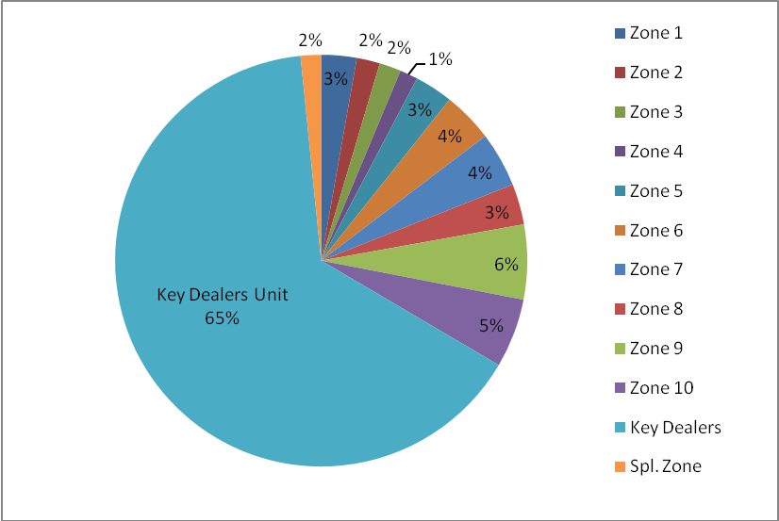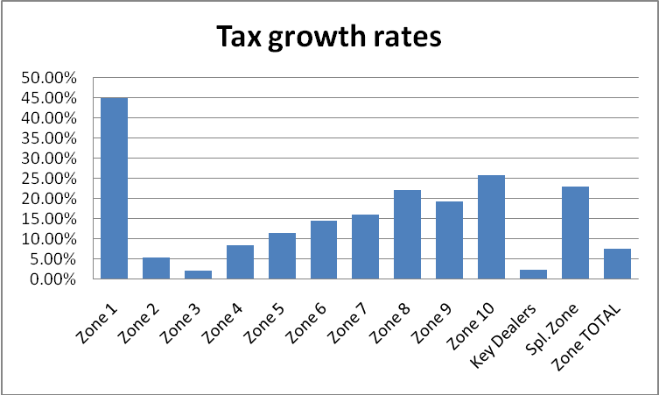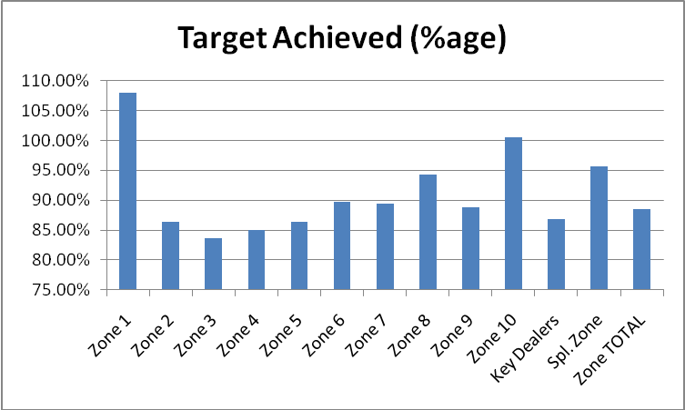
This analysis turns up some interesting findings:
- The Department on a whole has collected tax of Rs. 8941.48 in 2008-09 against a target of Rs. 10100 crore, which equals a 88.53% target achievement rate. Collection has grown from Rs. 8318.7 crore in 2007-08, reflecting a growth rate of 7.49%. It is important to note that the economic downturn in 2008-09 should be counted as a major factor influencing target achievement rate, because department officials may have under-estimated the extent to which business in Delhi would get affected by it. In fact, clocking growth of 7.5% in this economic environment is commendable, and the department deserves praise for not becoming negligent in collections even when they had an opportunity to use the excuse of the economic crisis.
- A prominent feature of the analysis is the Key Dealers Unit, which contributes a majority of the tax collections. At about Rs. 5806 crore out of Rs. 8941 crore, this unit constitutes 65% of Delhi’s VAT revenues!
- The other important ones by share of revenue (>5%) are Zone 9 and Zone 10. Zones 2, 3, 4 and Special Zone individually represent <2% of total collections.
- Only 2 zones (1 and 10) achieved their targets. 2 Zones (4 & Spl. Zone) were in the >90% category, and the rest were between 85%, except for Zone 3. Zone 2, 3, 4, 5 and Key Dealers Unit were below the average target achievement rate for the department. In particular, the Key dealers unit has fared badly in terms of target achievement- only 86.8% of target was collected, which translates to a shortfall of about Rs. 880 crores.
- The growth rate histogram shows a similar trend to target achievement rates. All Zones except 2, 3 and Key Dealers were above the average department growth rate. Key Dealers and Zone 3 were abysmally low at 2.15 % and 1.39% respectively.
- Using data in annexure, which breaks down zones into wards, there are a few notable findings:
 | Type of Ward | No. of Wards | Specific Ward numbers
1. | Wards with >95% target achievement rate | 26 | 1, 2, 3, 7, 15, 16, 27, 38, 56, 57, 61, 63, 70, 71, 77, 81, 83*, 86, 91, 97, 98, 99, 101, 102, 104, 105
2. | Wards with <75% target achievement rate | 10 | 4*, 12, 21, 24, 25, 34, 37, 48, 66, 74
3. | Wards with >50% growth rate | 5 | 2, 7*, 83, 90, 103
4. | Wards with <0% growth rate | 20 | 4, 5, 8, 10, 12, 18, 19, 20, 21, 23, 24, 25, 31, 34, 37, 41, 48, 66, 82*, 100
5. | Wards with > Rs. 50 crore tax | 10 | 2, 44, 61, 62, 63*, 64, 83, 84, 91, 104
6. | Wards with > Rs. 10 crore tax | 14 | 10, 13, 18*, 19, 20, 22, 23, 25, 29*, 30, 34, 36, 37, 40

Brief Rules of VAT
The first step in the new VAT system is that all eligible dealers have to be registered. Only registered dealers are part of the VAT system and can claim input credit. Dealers with a turnover of less than Rs.10 lack/yr are exempt from the system. More details on this will be in the chapter on Registration.
Following are the rates charged:
- 0 % (Items in First schedule) – essentials such as books, periodicals, newspapers, and maps, coarse grains other than paddy, rice and wheat, fresh vegetables and fruits, fresh plants, saplings and fresh flowers, and meat, fish, eggs, and livestock. These are exempted sales, i.e. no input tax credit can be claimed on purchase of them.
- 1 % (Items in Second schedule) – mainly bullion.
- 4 % (Items in Third schedule)- declared goods such as industrial and agricultural inputs, drugs and medicines, and capital goods.
- 12.5%- All other goods traded that are not mentioned in the other schedules. Also the rate for Works Contract.
- 20 % (Items in Fourth schedule)- e.g. Petrol, Diesel, IMFL, lottery tickets.
Generally, input tax credit will be eligible on all goods purchased for resale, raw material, capital goods, overhead materials and packing materials for use in the manufacture of goods. If the net tax payable is negative in a given period (input tax >output tax), then you have the choice of claiming a refund or carrying forward the excess to the next period to be claimed against the tax liability for that period.
The tax credit for capital goods can be claimed over a space of three years. You can claim credit for one-third of the input tax on capital goods at the time you buy the goods, one-third in the following financial year, and the remaining one-third in the second financial year following the year you acquired the goods.
Goods that are exported are eligible for input tax refund claims. Exporters are reimbursed for the taxes they paid on purchases because their sales are not for domestic consumption. Majority of VAT refunds are those collected by exporters.
Central Sales Tax rate is applicable on any inter-state transaction and equals 2%. A dealer can not avail any credit on the CST paid on inter-state trades. He can, however, off set his input credit against the CST collected from sales made to customers outside the state. Inter-branch transfers, across state boundaries, do not attract 2% CST.
All purchases must be recorded by preparing appropriate invoices. Three copies should be made- one for the dealer, one for the buyer, and one copy. The Invoice must carry all relevant details including the dealers’ Tax Identification Number to verify registration. The original tax invoices is necessary to claim input tax credit. The invoices must be preserved carefully to be produced in audit proceedings.
Tax can be paid, along with interest, penalties, dues, etc. to:
(a) a Delhi branch of the Reserve Bank of India
(b) a Delhi branch of an authorized branch of an authorized Bank- Several private and public bank branches are available for traders to easily pay their taxes.
(d) on-line Payment Scheme for dealers having bank accounts with particular banks.
The Tax period depends on the gross turnover of the dealer. The following table, modified from the Citizen’s Charter explains this:
GTO in preceding Year | Time Limit for deposit of tax | Periodicity of Return | Time Limit for filing return
GTO-Rs.10 lakhs or below | Payment of tax on quarterly basis within 28 days from the end of the quarter to which payment relates | Yearly | but return should be filed within 75 days from the end of the Return period, which is one year.
GTO above Rs. 10 lakhs but upto Rs. 50 lakhs. | Payment of tax on quarterly basis within 28 days from the end of the quarter to which payment relates | Half Yearly | but return should be filed within 45 days from the end of the Return period, which is six months.
GTO above Rs. 50 lakhs but upto Rs. 5 crores. | Payment of tax and filing of return on quarterly basis within 28 days from the end of the quarter. | Quarterly | The dealers filing quarterly returns are required to file returns electronically also within 25 days of the end of their tax period.
GTO above Rs. 5 crores. | Payment of tax and filing of return on monthly basis within 28 days from the end of the month. | Monthly | The dealers filing monthly returns are required to file returns electronically also by 25th of the month following the month of tax period.
Advantages, Disadvantages and Principles
Advantages
The following is a list of the benefits that a VAT system intends to bring to taxpayers, tax authorities and the economy in general:
- In-built incentive for voluntary compliance-
The incentive to claim input tax credit on purchases pushes the dealer to charge taxes on sales, for it is against output tax collected that he offsets the input credit. It forces him to work with other registered dealers in order to claim input credit, (input credit can only be claimed on purchases from registered dealers) thereby broadening the tax base. Broadening the base, in turn, increases revenues and promotes better record-keeping standards. In this way, VAT works as an automatic mechanism to encourage traders to comply voluntarily with tax collection
- Revenue Security-
Taxes are collected on all value added. Even if there is under-invoicing/ no invoice at a particular stage, tax revenue lost from the earlier stages is nil.
- Cascading effect-
This is eliminated by the provision of set-off of input tax.
- Cross audit-
In VAT, unlike the previous regime, tax invoices must be issued by all the dealers. The tax charged by a dealer on sale of good to another dealer is recorded by the latter as a deduction. He can only claim credit if the previous dealer has recorded and issued him an invoice. Thus, the tax authorities are able to cross-verify the transactions between dealers. It is only the final consumer who cannot be verified. The requirement of keeping invoices works as an effective self-policing mechanism by improving the scrutinizing power of tax officers.
- Self-assessment –
Due to the high costs of administration, the level of scrutiny recommended is only 10-20%. Instead, VAT relies on self-assessment by dealers. This considerably reduces face-to face time for taxpayers. Selective scrutiny serves as a good deterrent, by allowing honest traders to avoid regular harassment by tax officers while keeping the insincere ones worried.
- Transparency of taxes-
In a single-point tax, it is difficult to understand the effect of the tax on the price of good at other stages of trade. In VAT, one is able to know the tax at each and every stage of goods of sale or purchase. The sale price and the element of tax is depicted separately on the invoice. Consumers make more informed choices and economic analysis of the effect of tax becomes easier.
- Simplification of rates-
Earlier, under CST there were 8 types of rates- 1,2,4,8,10,12,20,25. In VAT, most goods come under 3 slabs- 4%, 12.5% and 20%. Also, there are no issues with the stage of the sale, i.e. where the sale is located in the production- distribution chain because VAT is applied equally at each stage. The only difference in rate may be because of the nature of good being traded, not the type of trader or stage of sale.
- Eliminates multiplicity of taxes-
With the introduction of VAT, a number of state taxes like, separate excise rates, turnover tax, surcharge, resale tax, lease tax, etc. were to be eliminated. This reduces excessive costs of filing returns for different tax types and lowers cascading effect.
- Integration of markets
With uniform rates across country and removal of extra state levies would level the playing field between states and bring about a more integrated national market for goods.
- Provide opportunity for upgradation of department’s IT infrastructure and building a robust online system for taxpayers.
- Time bound process for appeals.
- Filing of returns, procedures to submit forms, etc. to be simplified.
- Benefits for Income Tax assessment-
Since they need to claim credit for input tax, traders will be dis-incentivized to keep sales and profits earned off their books. With increased voluntary compliance with VAT rules, book-keeping standards will go up and therefore it will be harder to evade Income Tax.

Disadvantages
Following are some disadvantages of having a VAT system in its current form:
- Harder to administer- more complex and time-consuming for tax officers because of much broader tax base.
- Minimum fixed cost of compliance. Considered especially burdensome for small traders, for whom book-keeping requirements under VAT are costly.
- Anti-poor. Consumption taxes affect poor more since they spend more of their income on consumption than rich.
- Too much discretion with states to decide items in schedules (i.e. items under different VAT rates).
- VAT is inflationary. Introduction of VAT gives an opportunity for businessmen to increase prices, and can lead to a inflation spiral.
- A state administered VAT, as different from a centrally administered one, leads to problems with inter-state transactions.

The government has tried to address some of this criticism. For point 1, a policy of self-assessment with lowered scrutiny of only 10-20% has been adopted. For 2, the fact is that in any case most traders file extensive returns for Income Tax and to keep track of their transactions. Better record-keeping and book management by businesses will help in a number of other ways. For small traders, there are schemes to be excused from the VAT process that will be detailed in the chapter on Registration.
Though VAT is an indirect tax on consumption, and in that respect poor people may get affected more, it is important to note that the government has made sale of most essential items exempt from VAT. The worry that VAT is inflationary is not backed by hard evidence; usually, there will just be a one-time marginal spike and then prices will stabilize.
The criticisms that stem from India’s unique state administered VAT have some merit, and will be addressed in the Chapter on All-India issues. Please note that these issues are due to our particular version of state VAT, which undermines point 10 in the advantages list by not creating an integrated national market.

Principles of a successful VAT
The following are some broad principles. They have been adopted from “Internationally Accepted Principles of a good VAT” Presentation prepared by the Central government and recommendations in the Primer on Value Added Tax published by NIPFP, 2001. The over-arching goals are to promote voluntary compliance, reduce cost of collection, reduce cost of compliance, increase revenue and modernize tax administration.

- Tax on all transactions and minimum exemptions
- Appropriate rate slabs and schedules so as to avoid adverse effects on poor and eliminate cascading effects. A single, low rate with a broad tax base.
- Minimize face-to-face time between taxpayer and tax officers through simple system of self-assessment.
- Strong audit mechanism
- An enforcement system with a sound and effective penalty system
- Simple registration process.
- Adequate educational programs for taxpayers.
- Modern techniques of tax administration with robust IT infrastructure. A strong database for keeping track of transactions, returns, trade flows across state borders, etc.; reliable electronic data processing.
- Adequate online services for taxpayers, including electronic filing of returns
- An appropriate department structure and organization, with knowledgeable and well-trained personnel

Having established a set of advantages and principles for a successful VAT system, this paper will evaluate the Delhi department’s performance keeping them in mind. Has the implementation lived up to the principles it sought to adhere to? Has it provided the advantages that it was meant for? In the rest of the paper, the various points mentioned in this chapter will be kept as broad parameters for deciding whether or not VAT has worked well for taxpayers and tax authorities. The principles outlined above will also serve as a foundation from where further recommendations and suggestions can be given to improve the system.
Part B- The Issues
Launch of VAT
Registration
The new system of VAT brought along with it a changed registration process and eligibility criteria. Since under VAT all transactions are taxed, the tax base has increased significantly. In light of this, the registration process needed to be simple, quick and efficient.
The registration process is compulsory only for dealers having turnover over Rs. 10lakh/year. This way small traders with very low daily receipts can be avoided the hassle and costs of systematic book-keeping and regular filing of returns. Note that they still have to be registered if they are involved in any inter-state sales.
Leaving the small dealers out of the tax net does not really reduce tax revenues. A dealer with Rs 10 lakh turnover/ yr has a turnover of approx. Rs.2,700/ day. The margin for such a dealer is usually small, so that he hardly earns Rs.150-500/ day. As it is, the only tax that can be collected from him will be on his value-added. So the amount of tax involved here is extremely small. In practice, their exclusion saves considerably on compliance costs borne by them, as well as collection and assessment cost of officials. This allows authorities to focus on cases where larger sums of money are involved, rather than waste time on trivial matters. Additionally, this is a good step because smaller traders are particularly vulnerable to harassment by government officials.
Another way the government has made it easier for smaller businessmen is through the Composition Scheme. Dealers with less than turnover of Rs 50 lakh/yr can opt for this scheme under which they will be charged 1% tax on turnover. However, they will not be allowed to avail input tax credit on purchases or issue tax invoices that can be claimed by their customers for input credit.
These dealers may still want to register themselves under VAT so as to avail input tax credit and issue invoices on the transactions, if they feel the book-keeping costs are not a burden. It is possible that the customers of small dealers would prefer them to be registered so that input credit can be availed on purchases made from the small dealers. The government has allowed for voluntary registration for this reason.
Being a registered dealer entitles one to certain rights and entails certain duties:
- To collect tax through a proper invoice and timely payment of it;
- To claim input tax credit;
- To file periodic returns; and
- To prepare and maintain proper records and books of accounts.

The registration process has become less time consuming. If the applicant does not receive a reply within 15 days he is automatically registered. In case his application is rejected, the department must write to him the reasons for such a rejection. The establishment of a short, stipulated timeframe is a good measure. Also, if a dealer has more than are one place of business, he can apply for a single registration.
With registration, traders are now given an 11 digit Tax Identification Number (TIN). This is of immense help for creating databases, keeping records, online services for taxpayer such as e-returns, inquiries, etc. A special Centralized Registration Cell is located on the first floor of the VAT building to take care of all matters related to registration.
There have been mixed opinions from taxpayers about the registration process. The time-stipulation for return of reply is not adhered to at times. The taxpayer sometimes has to make return visits to the department in order to clear his registration, in spite of the automatic acceptance rule.
Some traders also still find it cumbersome to gather together all the paperwork necessary. However, since this is a one-time process, and with voluntary self-assessment being introduced with VAT, there is merit in asking traders to provide thorough documentation. The security amount of Rs. 1 lakh, with an option to reduce it to Rs.50,000/- provided certain additional information is furnished, is also reasonable.
While there are some problems with implementation, the rules stated seem appropriate. The department needs to improve its performance and adhere more sincerely to the guidelines. They should adopt a more responsive attitude toward feedback as well.
Education
After over fifty years of the Sales Tax regime, the switch to a modern, more efficient tax system meant adjustment for tax payers and tax officers alike. Awareness about how VAT works needed to be made easily available. Taxpayers’ apprehensions about filing process, online systems, change in tax liability, assessment, etc. had to be allayed.
The department did make efforts to educate taxpayers about the various changes with VAT. It released guide books and manuals explaining the salient features. It conducted numerous workshops, forums and conferences with relevant stakeholders like trade unions, tax advocates and chartered accountants. It also publicized this new system through advertisement campaigns in both print and electronic media. The expenditure on publicity campaigns has been approx Rs. 3 crore per year. The Citizen’s Charter prepared by the department is clearly written and easy to understand. It is an extremely helpful document for anyone who wants to understand the various rules for filing, registration, rates, complaints, department structure, etc. In addition, a dedicated VAT helpline was set up to answer queries of taxpayers. In its initial year, it was widely used by tax-payers to learn more about Tax Identification Numbers, tax rates, composition scheme and exemptions. The helpline does a reasonable job about answering queries regarding basic rules and procedures.
The department has two websites- one with the online facilities for taxpayers and the other with information about the department. Both websites have sufficient details about VAT. There is a Working Guide available which lays down in simple, yet fairly exhaustive terms, the rules and procedure for paying VAT. The FAQ’s prepared on VAT are extensive and able to clarify several concerns/ puzzles that one may have about the tax. The websites have lists of dealers (including cancelled and composite ones) and authorized bank branches for depositing tax classified by Zone, Ward and Market. The Citizen Charter, DVAT Act, DVAT Rules and other public documents can be viewed online. The senior officers’ contact details have also been made available on the department website, along with the details of the Appellate Tribunal. With regard to understanding the tax, the websites are a useful resource prepared by the department.
In terms of making an attempt to educate tax-payers about VAT, the department has implemented some helpful measures. Also, education about tax- procedures is a two-way game; traders, advocates and accountants must be pro-active in learning about the new system. They must change their approach of waiting till the last moment when payments/ assessments are due to study the procedures and steps involved. Since taxes do have an impact on their businesses, they have a stake in adapting quickly to the new system. This is all the more important because soon there will be another revamp with the Goods and Services Tax, and traders must be ready to spend time learning about the new rules in that system. The department should carry on with its efforts of workshops and publicity campaigns as this is a continuous process. The department will increase the effectiveness of its efforts by better advertising to traders the various resources it makes available such as manuals, guide-books, website links, details/ dates of forums and conferences, etc.

Compliance
Issues related to compliance are crucial indicators for judging the performance of any tax administration. One major goal of VAT was to bring down cost of compliance for traders by simplifying procedures and improving department functioning. Remember that, in spite of all its inherent benefits for traders, VAT has certain book-keeping costs that are necessary for all traders in the broadened tax base. In general, the opinion is that VAT has brought down compliance costs. The day-to-day operations have become more straightforward. The concept of self-assessment and selective audit greatly relieves stress for dealers. The rules and policies are much more taxpayer- friendly, and the department also took this opportunity to revamp the way it works. Many traders, advocates and accountants believe VAT has been an improvement over its predecessor and that levels of harassment have decreased substantially.
However, taxpayers also caution that there some glitches still exist in the system. At times, procedures and rules can be cumbersome and onerous. The department’s efficiency in executing certain functions is wanting. The rest of this chapter will discuss the various problems confronting taxpayers and VAT authorities with regard to compliance.
Forms, documentation, filing
The issuance and acceptance of forms, applications, letters and other documents has become less time-consuming than before. The office infrastructure has improved and computerization has made things quicker. Dealers can also look up application status for forms and registration online. The extremely tedious and time-consuming declaration forms from the previous Sales Tax regime have been removed.
However, it can still be a long process at times. The number of counters in the department is not adequate to handle the daily traffic of applications. The IT infrastructure is still going through a transition phase and is not up to the mark presently. Dealers are asked to bring proof of documents that should already be in the department’s computer system. The filing system is not well-organized and many letters, intimations, etc. submitted are not recorded in the system, and dependent on the physical receipt carried by submitter. If a dealer’s Ward has changed due to change of address or shifting to Key Dealers Unit, then the new Ward makes the dealer run around to get copies of original document from previous Ward. All papers related to a particular dealer are not filed at one place- e.g. refund papers are put separately for some. Finally, VAT files have not been merged with old files from Sales Tax for some dealers.
The department needs to take more targeted steps at improving efficiency in day-to-day dealing with taxpayers in this area. The number of counters should be increased. The filing system needs better record- management. Since the IT system is currently being upgraded, a number of problems related to day-to-day filing should be solved when that is completed. When Ward is shifted, then the department must see to it that original copies get transferred to new Ward officers; if this is too tedious, then they should accept photocopies of originals submitted previously along with receipt of submission. The filing of documents for dealers needs to be compiled more systematically. This will help the department officers more than anyone else in the long run.
One troublesome issue for dealers is the staff that sits behind counters to feed in data from the forms. These data ‘feeders’ are unskilled and highly incompetent. They fill in incorrect data or incomplete forms at times, which then get rejected. Taxpayers have to return to the department to make amends for their errors. The department has outsourced this work to an outside firm. The workers hired are paid very low salaries and they stay in the job for a short time. They are not employees of the department so they are not answerable to anyone. Such a situation should not be allowed to continue much longer. Since the department is unable to staff these positions itself, performance standards must be kept in place for the contractor. There should be periodic review of the feeders’ work, and if it not up to the standards, then they must take steps to penalize/ replace the contractor. Also, currently the feeders are not trained adequately when they are hired. The contractor could be suggested to approach CMC Limited, the firm in charge of computer-training for officers, to take responsibility for training new feeders as well.
Some traders complain that they should not be asked to fill forms DVAT 30 and 31. DVAT 30 is the purchase register and DVAT 31 is sales register. Each requires the trader to create a list of each transaction (purchase and sale for 30 and 31 respectively). If a trader had not been doing this in previous years, then this could be quite a tedious exercise. Also, traders may have been doing some version of this but in a different format than prescribed.
DVAT 30 and 31 are not mandatory to file, but must be prepared in case of audit. The department hopes to make it mandatory once the IT up gradation is complete. The argument in favor of requiring DVAT 30, 31 is stronger than traders’ inconvenience about it. Maintenance of a Purchase and Sale register is the minimum book-keeping that should be required under a VAT system. It makes assessment much more efficient by helping tax officers carry out a quick and accurate audit. In case of format hassles, if the format used by a trader carries sufficient details and closely resembles the prescribed format, then he should be exempted from repeating the same process. With the new IT system, this issue is also expected to be solved.

Central Forms
One of the most commendable steps under VAT was to do away with all statutory/ declaration forms required under the previous Sales Tax Act. This has made life much easier for tax payers. However, statutory forms (C, F, H forms) are still required under the Central Sales Tax Act, 1956 for inter-state sales and branch transfers. Obtaining and submission of these forms is a haranguing process. First one has to fill a requisition, then the authorities verify the application with the returns and finally the forms are given. This involves a lot of wastage of time and expenses. Since the department cannot really change the nature of these forms (under Central act), the least it can do is simplify the process of obtaining them for dealers. One way is to make these forms available for issuance on-line, like the Gujarat Government has done. Second is to have automatic issuance of form by post within a stipulated time period after application has been made. This is done in Haryana and Maharashtra, where forms get sent by post to the dealer after he has applied online. There should be facility for online check on status of the pending application as well.
As noted earlier in the paper, mismanagement of F-forms has led to loss of significant amount of revenue for the government. When branch transfer of stock is made across borders, it is exempt from Central Sales Tax. For this, dealers have to file F-forms. In 2007-08, the CAG reported that Rs. 782.73 crore was lost due to poor performance appraisal of exemption of Central Sales Tax on account of branch transfer/ consignment sale. Some of the main reasons pointed out by the CAG for this were:
- Absence of data base of tax exemption on branch transfer/ consignment sale
- Absence of monitoring mechanism to ensure cross-verification of ‘F’ forms
- Misutilisation of forms- forms were issued to dealers other than the ones who claimed exemptions.
- Fake forms
- Excess exemption claimed by dealers
- Inadequate mechanism to ensure proper maintenance of records of ‘F’ forms
- Scrutiny of returns
- Inefficient Internal Audit
- Exemption of tax without submission of ‘F’ forms/ incomplete forms/ duplicate portion of ‘F’ forms
- No action against defaulting dealers

They have recommended
- creating a data base of exemption of tax on account of branch transfer/consignment sale;
- prescribing a periodical return/statement by the assessing authorities to the superior
authorities about the number of ‘F’ forms required to be cross verified, actual number of forms verified, reasons for shortfall, if any;
- evolving a mechanism of periodic review of the stores/stocks of ‘F’ forms by the higher authorities to ensure proper utilisation of ‘F’ forms; and
- taking immediate measures for effective functioning of the internal audit cell.

While under-assessments discovered by the CAG had been decreasing since VAT’s launch, this glaring malfunctioning by the department with respect to F-forms has cost the citizens of Delhi a large amount of tax money that should have spent for their welfare. This issue needs to be dealt with strictly and the above measures must be taken to ensure that such large-scale mismanagement and fraud is not repeated.
Cross verification during scrutiny must be done thoroughly in cases where the probability of evasion is high. For exporters, the incentive to claim excess input tax credit is high because they receive it as a refund. According to CAG reports, Delhi regularly loses some revenue on account of this type of fraud, though it has dipped recently. Cross-audit is a useful advantage under VAT and authorities should utilize it well.
One other area where authorities face fraudulent claims from dealers is on inter-state sales. The rate on inter-state sales is 2% as opposed to 12.5% for within state VAT sale, so traders try to raise bills in Noida and other satellite towns even when the sale is made inside Delhi. This problem should be solved when CST is finally phased out. Till then, authorities should be more careful to scrutinize returns and receipt of statutory ‘C’ form by valid due date through reconciliation statements in DVAT-51.

Payment of Taxes
Authorizing deposit of taxes through several public and private bank branches has been an excellent step in improving tax payment services for traders. There are a large number of branches available for dealers to deposit their VAT collections. Online payment of taxes is another commendable reform to make life easier for taxpayers.

Taxpayer-Tax authority interface
Face-to-face contact with tax authorities was supposed to have decreased with VAT, and to a large extent it has. However, there have been complaints of misuse of Section 59(2) of the Delhi VAT Act, 2004 which authorizes the Commissioner to summon dealers to the tax office to furnish additional information as deemed fit by the department. Many traders, even those who are local composite dealers, have been sent notices to furnish details related to Central Sales/ inter-state transactions. Even though traders should be able to send letters for such clarification, some Wards do not accept the letters and require the trader to come to the department. The VATO is further emboldened by Section 86(14), which imposes a penalty of Rs. 50,000/- on any trader who “fails to comply with the requirements” under Section 59(2). This particular part of the act is very loosely worded, and gives very broad power to the VAT department to impose penalty at will on traders. Additional visits to the department like this can only create resentment amongst traders for the department and give opportunity for bribery to avoid harassment. Since adequate letters and documentation can be sent in case need of additional information, the section needs to be amended to allow for dealers to write back to department queries in such situation. The penalty provision also needs to be carefully re-worded; if that cannot be done, then the penalty amount must be reduced considerably. The department must learn to use such discretionary powers only on an exceptional basis.
Bread and Butter stories
I was told a rather interesting explanation (not verifiable) for the misuse of Section 59(2). Since scrutiny has gone down considerably with self-assessment, thereby reducing contact with taxpayers, the department officials needed to find a way to earn their “bread and butter”. The best way to do this was through provisions in section 59(2). Ironically, some accountants have started calling the process of VATOs interacting with dealers by using 59(2), “assessments proceedings”. This defeats one of the primary advantages/ principles of VAT- self assessment.

Penalties, Scrutiny and Appeals
Penalties
The high penalties under VAT touch a sore point amongst nearly all dealers, tax advocates and accountants. Penalties range in amount depending on the nature of the penalty. For certain wrong-doings like omissions, false statements, fake documentation, claiming wrong input tax credit, etc. there can be a penalty of up to Rs. 1 lakh or an amount equivalent to tax deficiency (or a percentage of it). For others, like errors in record keeping or stock-registers, the penalty is equal to Rs. 50,000-/ or 20% of the tax deficiency. For incorrect invoices the levy is Rs. 5000/- or 20% of deficiency. In almost all these cases, whichever penalty is greater usually applies. The imposition of penalties has become an automatic process now.
Smaller traders are especially upset about the high penalty amounts. A few unintentional mistakes with record keeping can lead to high enough penalty amounts that the business would have to be closed down. When recording detailed accounts of transactions hundreds/ thousands of purchases, it is possible to make a few errors. The chances of this are higher if you are not using good accounting software to record transactions.
Some tax consultants believe that a distinction must be made between an error/ omission caused by some mala fide intention and one that is the result of an inadvertent mistake. They argue that nearly any and everyone is penalized right now, and penalties have become a tool of threat that may be used by VAT officers to intimidate traders. To support their argument, the appellate tribunal is known to be soft on appeals against penalties; sometimes it even reduces the amount of penalty imposed. A reply from the Legal Cell of the Department to the RTI filed by me stated that there are 632 appeals involving imposition of penalty that were filed with the Appellate Tribunal since the introduction of VAT, out of which “in 60 cases, the penalty amount was reduced/ made void y the Appellate Tribunal till 30-06-2009” (see Annexure) . Another argument against high penalties is that they are so high that no one pays them in any case; instead, they negotiate with the officers to pay a lower amount as bribe.
While I agree that the high penalties can be painful for small traders, there is merit in keeping penalties higher than dealers would prefer. The fact that dealers are complaining about it is not all that bad a sign. This will also force them to raise the bar for their book-keeping and accounting standards- something that would be beneficial for them and authorities in the long run. If the penalty imposed does in fact impact the business in a very adverse manner, it is likely that the effort of filing an appeal is worth it for the dealer in any case. The appellate body should continue to be understanding of smaller dealers and allow for moderation of penalties levied.
The automatic process of levying penalties is a good step because it reduces scope for subjective judgment by VATO. The VATO ideally should not be the one to decide whether a mistake is intentional or not- that would open to much room for bribery. But if a VATO does get a case that closely resembles other cases where appellate body has repeatedly reduced amounts, the VATOs should take notice of that situation and similarly be lenient then. They should record in writing the cases referred to and the similarity in the case on hand. The appellate body can help in this process by suggesting conditions under which such leniency should be shown, and to what extent. one knows that the penalty can be appealed against successfully, then the hassle of going through an appeal process should be avoided. The appellate body could possibly make these guidelines easily available not only to VATOs but also to traders, so that traders can cite them as reasons to the VATO if the VATO is reluctant to reduce penalty on his own. They can make it a routine process after completion of hearing of appeals related to penalties. Additionally, this would save on the Appellate body’s time by having fewer cases to hear.
The argument that high penalties only lead to bribery is plausible, but still does not mean that the rule of high penalty does not serve its purpose. The high penalty increases the amount of bribe demanded, and still acts as a deterrent for traders. Even if penalties are moderated the same problem may exist- just the level of bribery will change. Tackling corruption of this sort requires much broader attitudinal shifts, both on part of the tax authorities and payers.
There is one place where change of Act for moderation of penalty amount does seem a reasonable request from traders. The “whichever is greater” clause for penalties should be removed for those subsections of section 86 (the penalty section) that relate to incorrect record- keeping/ invoices– e.g. subsection 13, 16. These are not the sub-sections used for fraud/ misrepresentation of information, and therefore errors of this nature can be innocent. Changing the “whichever is greater” clause to “whichever is lower” will allow for a portion of the tax deficiency to be recovered by the department. If the department deems fit, they can even increase the portion of tax deficiency to be returned from the current 20% to a higher level. Consequently, traders will be motivated to pay much closer attention to high value transactions, and the department will not lose much revenue on account of mistakes.
At this stage of the paper, a mention must be given for the nature of corruption involved in taxation. Unlike other government-citizen relationships where the citizens need to bribe the government in order to receive services, in taxation the citizens wish to bribe officials in order to give the government less. In the former type of interaction, the bribe given by citizens is a loss for them and a gain for the official. In the latter type, i.e. taxation, the bribe given is a gain for the citizen in the form of saving taxes, as well as gain for the official. So here one is working with a dynamic where both players are rewarded by subverting the law.
Traders themselves have a lot to hide. Harassment by tax officials can go only up to a certain extent if one has been an honest and regular tax-payer. All traders have access to departmental appeals process, as well as the option to take legal recourse. The main problem for these traders is the delays and harassments associated with day-to-day operations, small bribes that hinder smooth business, etc. Beyond that, it is the responsibility of the trader to avail the appeal process provided by the department on their own.
Scrutiny
The self-assessment nature of VAT was instituted in order to compensate for the large number of dealers who would be brought under the tax net. The department now is supposed to just focus on a small percentage of dealers for audit. Large taxpayers, who provide a bulk of tax revenue, are given priority in selecting audit.
One major problem with scrutiny is manpower shortage. As a result, only 5-10% dealers are selected for audit even though the appropriate level should be 10-20% for effective deterrence and revenue recovery. Second, large tax payers have complaints with the audit process. They feel that audits on them (every year), combined with the fact they have to file returns and pay taxes every single month, are too frequent and unnecessary. They would be more comfortable if one audit would take care of the previous 2-3 years. Also, the attitude of scrutiny officers can sometimes still be ‘raid-like’, even though it is a scheduled audit, not a raid. For large tax-payers, for most of whom their billing is already computerized and invoice-based, this attitude is particularly annoying to deal with. The businesses are informed just 4-5 days in advance, which is neither here nor there. On one hand it gives enough time to any dishonest trader to hide any fraud (assuming that he hasn’t thought of how to do so throughout the year in any case, even if the audit was unannounced), and on the other it does not give the honest ones enough time to prepare everything in order for the auditing officer. Also, the attitude of the officers is still to think of an audit in terms of the amount of revenue target that he has to collect, instead of speedy disposal, customer service, etc.
In my opinion the complaints of large taxpayers should be recognized, but some are not too compelling. The main problem regarding shortage of staff is an issue that the department needs to chart out a plan to solve. Leaving it unattended will only lead to loss of a lot of potential revenue. The raid-like attitude of the officers should be toned a bit, but in a sense it also serves as a good deterrent for dealers that are not being scrutinized. However, to the extent that large taxpayers do have concerns they wish to express and can be informed earlier about scheduled audits, they should be. This is particularly relevant for large taxpayers whose businesses run on a robust computer- based billing system. If the officer has vetted the computer system already, then the attitude to adopt should be cooperative rather than confrontational. The monthly assessment for larger taxpayers is a policy decision adopted by many states for VAT, so that should not be a problem. In any case, once the online system is fully operational, returns will be even easier to file.

Good Dealer Scheme
This is an innovative new scheme brought out by the department. Dealers who register 5% higher tax growth rate than the average growth of tax in the sector continuously for the last three years will be honored as good dealers:
- They shall be given a Certificate and Momento by Hon’ble Chief Minister / Finance Minister.
- No increase in security deposit for one year for issuance of Forms.
- No inspection/adverse survey of such dealer shall be conducted unless specifically approved by the Commissioner
A list of Good dealers will be out up on the website. Only dealers who meet following conditions will be eligible:
  - No objection or appeal is pending as on the date of selection of good dealer before any Assessment Authority / Appellate Authority / Tribunal / High Court / Supreme Court, and
  - No Enforcement action in the last 5 years, and
  - No late filling of returns and reports as prescribed under the DVAT Act – 2004 & Rules
This is a great step forward by the department in improving relations with dealers and motivating them to become honest taxpayers.

Note- Above details are from Notice No. F.3(162)/Policy-II/VAT/Misc./09/843-852, dated:6|2|09.

Appeals
Information on Appeals was obtained through RTI application filed on 13/7/2009. The following tables are from the reply sent by Legal Cell of the Department on 31/7/09 by Mr. D. P. Arora, VATO (L&J)/ PIO (full letter in annex).
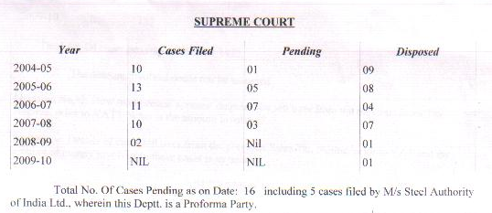
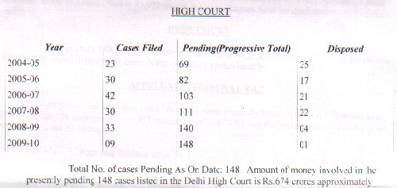
In the Supreme Court, all pending cases are old ones from the previous tax regime. In the Delhi High Court, the number of cases filed has been consistently around 30 for the past few years. The worrying aspect is that the number of disposals has been just 5 since last year, leading to a pile-up of 148 pending cases. The total amount of Rs. 674 crore is not a small amount, and the department’s legal department should actively focus on completing pending litigation. As suggested later, the department could ask for legal help from the Delhi government to sort out these cases on a high priority.
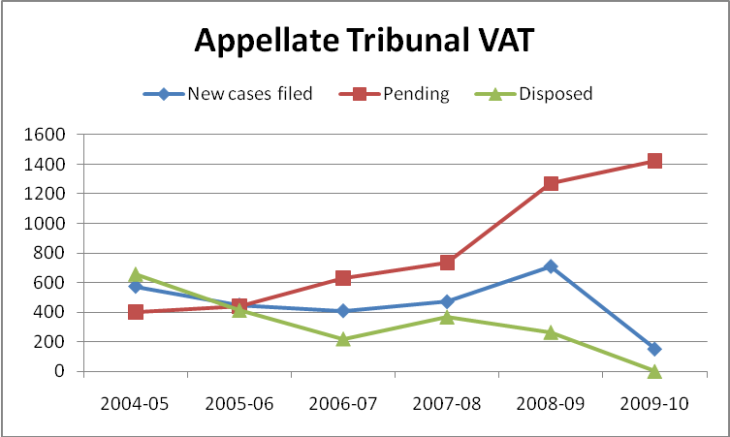
 | till 2004-05 | 2004-05 | 2005-06 | 2006-07 | 2007-08 | 2008-09 | 2009-10
Cases filed |  | 574 | 449 | 410 | 471 | 708 | 153
Pending | 485 | 403 | 440 | 631 | 735 | 1269 | 1422
Disposed |  | 656 | 412 | 219 | 367 | 264 | 0
Cases filed with the Appellate Tribunal have been increasing since the introduction of VAT, and their number touched almost 800 in 2008-09. Yet, the number of cases being disposed by the bench is decreasing every year (except for 2007-08). More worrying, the no. of new cases filed has been more than the number cases disposed every year since 2005-06. The number of pending cases has reached a staggering 1422. Last year, 2008-2009, was a particularly poor year for the bench; out against 708 new cases only 264 cases were disposed. In 2004-05 and 2005-06 the Tribunal did a good job of settling disputes. The amount involved could not be assessed.
The Appeals process is shown in the chart below:
Department serves order on dealer
(1st appellate authority) Dealer files written objection to department
Within 2 months of order.

Department gives decision on objection. If no decision given within time frame, then objection deemed accepted. Within 3 months of objection- +15 days extension. The department is given a further 2 month extension, if it gives notice to dealer in writing.
Dealer appeals to Appellate Tribunal. Within 2 months
Appellate Tribunal has no time line. Dealer can then appeal to High Court, and further Supreme Court, against decisions.

Making appeals time-bound under the first appellate authority has been a major reform. This has made the grievance redressal mechanism for taxpayers much faster and more approachable. The Appellate Tribunal does not have a time-frame, but since the cases there are to be decided by experienced judges it is appropriate to not put an external time constraint on them. For this, there could be some sort of time-frame that the tribunal can set for itself when it first hears a particular case. Currently, traders waste time waiting for hearings and in finding out status of appeal application. The appeal process could be further streamlined better by introducing online service for checking status of appeal and appeal application, date, timing of hearing, and other details.
The clause in section 74(7) that provides for an extension by two months of the department’s decision on an objection is unnecessary. It only serves to dilute the 3-month time-frame put in place for departmental appeals. This clause should be removed or should be reworded so that only in exceptional cases and with elaborate explanation of reasoning can the department extend the time. Right now the department can extend the period by 2 months on any ground, so long as he notifies the dealer. In any case, there is already an extension of 15 days that the department gets in case it does not notify the dealer of any decision under section 74(8) and (9). This provision for an extra 2 months under 74(7) should be scrapped.
Pending appeal cases from the Sales Tax regime are not subject to any time-period as cases under VAT are. As a result, revenue is still stuck in appeals from these old cases. Information on no. of cases and amount of money involved in cases from previous Delhi Sales Tax regime was obtained through same reply to RTI used to create previous table (annexure). Note that these cases are already included in the total number of cases given in above table on total appeals pending.
Previous DST Cases | No. of Cases | %age of total cases | Amount involved
Supreme Court | 16- All cases in SC are from DST Regime | 100% | Rs. 972 crore
High Court | 123 | 83% | Rs. 647 crore
Appellate Tribunal VAT | 98 | 7% | Cannot be assessed

Under section 74(10) of the DVAT Act, 2004, the department should have disposed off all these cases by 5 years from the commencement of the Act in April 1, 2005. Under section 74(11) of the Act, if these cases are not solved by that time, then they will be deemed to be accepted in favor of dealer. The department must make a dedicated effort to finish and retrieve the revenue due from them. For the SC and HC cases, the department should seek additional legal aid to complete litigation. The sum of Rs. 1619 crore that is locked up in these two courts could be well used by the state government. They could do this by directing the Tribunal to appoint a few new members who would work for a temporary period to hear and decide only the old cases from Sales Tax. This separate bench would aim for quick disposal of these cases by the deadline given in the Act. It is imperative that so much locked up revenue due to the department is not lost because of delays by the department.
One problem that some taxpayers believe delays the appeals process is the lack of understanding of law by the VAT officers. As a result, the first appellate authority is not confident enough to give his own judgment on the first objection made. He then waits for the objection to go to the Appellate Tribunal. The only solution for this is better training of officers. The next chapter, on Departmental Issues, will discuss problems related to staff training in detail.

Departmental Issues
This chapter will discuss issues revolving around the department’s structure, organization and functioning that have impeded efficient tax administration. Some key issues that will be looked at are manpower shortage, training and functional versus geographical classification.
Manpower shortage
The most difficult problem facing the department is shortage of staff. This problem has prevented them from carrying out a number of their responsibilities efficiently. Work and cases pile up. Senior officers are kept busy with day-to-day operations rather than being able to spend time on continuous structural reforms of the organization. This is a dangerous situation to persist for a tax authority in particular because delays lead to loss of revenue to the exchequer. An overburdened staff may mean that a lot of potential revenue is just left uncollected, since officers do not have enough time on their hands.
As mentioned previously, scrutiny is one key function that is adversely affected by the lack of officers. Only 5-10% of registered traders are scrutinized, even though the appropriate number was to be 10-20%. Officers are stretched when time comes for scrutiny, not able to cover all the dealers it would like to. Scrutiny is arguably the most important function with respect to recovering taxes and deterring other traders. A weak scrutiny process, caused due to inadequate number of officers, contributes both directly and indirectly to revenue loss.
There is a shortage of staff at the VATO and AVATO levels. Many traders and accountants have complained that there are some Wards with less officers than needed. Consequently, work gets delayed, amendments are not carried out and assessments become pending. In addition, information that needs to be fed in by the VATO may remain incomplete. The only solution for this is to hire more officials, because work at the VATO level may not be prudent to outsource.
Finally, the record-keeping staff also needs to be increased and made more efficient. One way to fix this is outsource the routine work related file-keeping to an outside contractor. To avoid problems as seen with the data-feeders, performance standards must be explicitly mentioned in the contract, as well as penalization for not adhering to them. The department officials made in charge of overseeing and reviewing the work of outside contractor must give regular performance reports. The reports should be checked so that feedback from traders, tax consultants and others who come to the dept. regularly concur with the review.
No Dedicated Revenue cadre
Officers appointed to the Delhi Department of Trade and Taxes come from the general pool of IAS officers, not from any dedicated revenue cadre. In other states as well as Centre, there is a dedicated revenue cadre of officers from where they may be sent to the state’s Sales Tax/ VAT department or the Central Income Tax/ Excise/ Customs department. In Delhi as in other states, the Commissioner is appointed from the general IAS, while the deputy/ joint commissioners are from Dainik Services. At this level, the officials are well-educated and well-trained to carry out functions. But rest officers are from administrative services, not from revenue. Consequently, they are untrained about working in tax administration. Posting to the VAT department is sometimes seen as a lucrative option, undermining merit capabilities as a qualification for transfer into VAT.
While civil servants are usually well-educated and capable to migrate from one executive function to the next, VAT requires specific knowledge of accounting, law and procedures. Officers must be able to understand the causes and objective of tasks that they perform, instead of just following prescribed instructions. As mentioned before in the chapter on Appeals, this can be a problem when the officer is hesitant to use his own understanding to make decisions, because his knowledge is vague about the issue. In day-to-day operation of a tax administration, where a variety of issues and cases crop up regularly, each with its own unique aspects, those officers are needed who can logically tackle issues keeping in mind the rationale behind rules, not just the exact text of them. Moreover, it is only when the officer is highly knowledgeable about his subject matter that he can recommend modifications/ changes to procedure to adapt them to new circumstances. As such, training is a necessary condition for effective responses to constructive criticism and feedback from taxpayers.
Delhi’s VAT department is in urgent need for a dedicated revenue cadre. The Public Accounts Committee (PAC) of the Delhi Assembly headed by Congress MLA S. C. Vats had recommended this way back in October, 2005. Action has still not been taken in spite of the numerous problems faced by the department due to this situation. The lower and mid- level officials require some more permanency in case they are expected to become knowledgeable about the job.
The department can also solve this issue by instituting a more rigorous and thorough training program. The training program should be designed so that it is extensive and includes follow-up sessions, with a focus on explaining the rationale and reason behind rules, procedures and the law. An effort should be made to ensure that the officers will be confident at the end of training to use their own understanding of laws/ rules to make judgments. Moreover, a robust training program would have positive fall-out effect on several other issues discussed till now.

Functional versus geographical classification
One structural reform suggestion for tax administrations is to classify themselves along functional lines instead of geographical lines. Currently, the officers in DVAT are assigned Wards in particular Zones. There is some degree of division of responsibilities based on function (different functional branches as listed in Chapter on Department), but this is only to an extent and for only very specific wings like Audit, internal administration, etc. In general, VATOs working in a particular Ward take care of most issues related tax for dealers registered under their area.
The argument for functional classification is mainly for two reasons. First, functional classification improves specialization. The officers in charge of a particular task can be chosen from the respective fields that they are experts in. Second, geographical classification encourages the VATO to hold wide discretionary power and develop a relationship with the dealer, which encourages harassment and corruption. In functional classification, different officers will be responsible for separate tasks, so the power of each officer declines.
Though this seems like an excellent reform suggestion in general, there are reasons why it may not be fruitful as expected. Firstly, in Delhi there is only one head office where everyone is located. The culture of corruption is a problem in general and cannot be simply broken by making them perform specific duties. As mentioned before, this requires an attitudinal shift, both among tax authorities and tax payers. Also, even with functional classification, there is no reason why there will be less corruption when dealing with officers within a particular functional division. Secondly, and more crucially, functional classification will greatly increase the time and cost of dealing with department for dealers, since they will have to approach different sub-authorities for different issues. It is easier, faster and cheaper to deal with one officer, who will be able to look at the dealer’s tax problems in a holistic manner.
Instead of functional classification, the department should merely focus on better training of VAT officers in general. They should not compromise much on either breadth or depth of knowledge when it comes to law, accounting concepts, rules and procedures. In any case, some functional classification has already been done for certain specific tasks. Further classification can be encouraged, though the department should be given flexibility to decide for itself the pace of such reform.
Voice of traders
For any government department, the active participation of citizens in f.unctioning and reform discussions is necessary for good governance. In this regard, the department hires external consultants to give tax policy advice and regularly organizes forums to discuss problems and concerns of dealers, tax advocates and accountants. The senior officers are approachable and amenable to suggestions. The department has also set up a VAT Advisory Committee consisting of over 250 traders across Delhi.
However, for tax, the participation of citizens in discussions with government officials is a tricky issue. Traders are scared to openly criticize the department for fear of being hounded by department officials later. Every single trader I spoke to strictly requested to keep his name confidential. While the VAT Advisory Committee does serve as a good forum, tangible response can only be given to written complaints. Consequently, a lot of potentially constructive feedback that traders could provide remains unheard. This is detrimental to the department because traders have several useful suggestions regarding small rules and procedures that would reduce costs in the long-run for the department themselves. Additionally, the input of dealers is a must for effective monitoring of performance of low-level office staff in charge of filing and data-feeding. It is only when such feedback is collected that the department can come to terms and make amends for sub-standard work by staff.
The issue of traders’ participation still remains a tricky issue, because it is ill-advised for the department to act on general verbal complaints by dealers. Instead, the department should summarize grievances/ suggestions put forth at the various forums it organizes. It should have periodic review of any suggestions to do with rules/ procedures that have come up in that period- either in writing from traders, during forums or from various VATOs themselves. Recording and responding to advice from the people it serves and deals with is a policy that would greatly improve the department’s performance.

Computerization
When VAT was introduced, the department seized the opportunity to undertake modern computerization of its systems and infrastructure. Computerization and upgradation of IT systems is still in its nascent stage. CMC Limited and HCL Technologies are carrying out the software and hardware work respectively. Currently, the department is in a transition period. Therefore, issues related to computerization should be judged with patience. This section will deal with some of the key problems related to computerization that currently confront the department. It will also suggest new measures that could reduce compliance and administrative costs.
Online facilities for taxpayers
The department has made many services available online for the dealer. Online payments are now accepted through authorized banks. The dealer can file e-returns now. There are a number of other web-based facilities available to the dealer such as application status for forms and registration, finding out TIN, etc. Mobile-SMS based application and information services have also been implemented for dealers. As mentioned in the chapter on Education, the websites are well-maintained and have ample information for taxpayers. The introduction of this vast array of web-based facilities for dealers has surely made their job of paying taxes and filing returns significantly easier.
Many traders are annoyed that in spite of having e-returns, they still have to submit manual documentation to the department. This results in duplication and defeats the purpose of having an online facility. However, requiring only e-returns cannot be allowed unless a foolproof system for digital signatures is available. The department is aware of this and is in process of obtaining hardware for the same.
As mentioned in previous chapters, there should be online features to look up status of appeals and hearing timings. DVAT 30,31 should be easy to file, with large taxpayers able to configure their software to department-prescribed formats. A web-based issuance and application system for Central Statutory forms C, F and H should be created. The computerized acknowledgment services available in Key Dealer’s Unit should be extended to other Wards.
One major hassle faced by traders is that near the end of month/ quarter, when returns are to be filed, the server crashes. The site gets jammed in the last few days of filing. It is unrealistic to expect normal level of usage traffic in those last days, and therefore, requesting traders to file returns earlier is not a solution. The server capacity needs to be augmented urgently.
IT infrastructure/ electronic database
As you can see from the chart, there are a number of software solutions that are being used by the department. Some changes are also being made to accommodate amendments to the Act and modify formats. Establishing a strong IT system will be of immense value when GST is rolled out, although some of the programs will have to be modified to the new tax system.
IT Solutions for Delhi VAT department (CMC Limited)
S.no. | Name | Remarks on future up-gradation work
1 | Dealer Information System (DIS) | New forms added
2 | Returns Processing System (RPS) | New format (e.g. DVAT-16)
3 | Dealer Audit & Assessment System (DAS) | No change
4 | Tax Accounting System (TAS) | Format changes (e.g. challan format)
5 | Transitional Regime (TRM) | No change
6 | Advisory Visits (ADV) | No change
7 | Arrears Recovery System (ARS) | New forms added
8 | Objection & Appeals System (OAS) | No change
9 | Penalty & Offences System (POS) | Format changes
10 | Enforcement & Raid System (ERS) | N/A
11 | Management Information System (MIS) | Adding new reports to this
12 | Refund Processing System (RFS) | Format changes plus some new department requirements
13 | Goods Movement System (GMS) | No change
14 | Check-post Management System (CMS) | No change
15 | Personnel Information System (PIS) | Not being used properly

One area where the department needs to tighten up its IT systems is in its internal database for keeping track of Central forms. This is an important recommendation made by the CAG that must be followed after loss of substantial revenue in 2007-08 due to mismanagement of these forms. Another area is the Personnel Information System, which relates to profiles of the VAT officers and their work. The officers need to fill data in this system more regularly for better internal management.
In terms of tracking inter-state transactions, a web service has been created by the Central government- www.tinxsys.com. Updating this database regularly and sharing information on trade flows in and out of Delhi will help recover large amounts of tax due to evasion on inter-state trade. With the GST coming in soon, this is very important because GST will need effective monitoring related to input tax credit claims in other states. Delhi has often been criticized by other states for unaccounted goods coming out from within its borders; a sincere effort by the department to fill in data online will serve as a good example for other states, which will help Delhi in turn. Quarterly reporting for this database will aid cross-verification of inter-state transactions and reduce dependency on the archaic, inefficient, and corrupt check-post system used currently to regulate inter-state trade. The Delhi government must also appeal to other states and Centre during GST discussions to make it mandatory for all states to update this database regularly.
Training of department staff
While the department has made commendable strides in computerization since the launch of VAT, there is a serious problem regarding lack of proper computer-trained officers. Many officers are not adept at using computers and may delegate computer work to younger officers. CMC, which is in charge of computer software solutions for the department, has had to install biometric devices for officers who were not able to learn how to use a mouse. This is a severe hassle because now a lot of departmental work is computer-based. As a result, the existence of computer-illiterate officers can lead to several delays and errors.
The only solution for this is a rigorous computer-training schedule for officers. Currently CMC trains only 2-3 batches for 5 days every week. This needs to be made more frequent with regular follow-up sessions. At least one batch per month is required. As mentioned before in the chapter on Compliance, CMC can also be employed by the contractors in charge of data-feeders to train them. One reason behind the low computer- proficiency among officers is that a number of them are old and soon to retire. The department should take note of this so that when transfers are made to the Delhi VAT department from other IAS bodies, those who are well-trained in using computers are given preference. Computerization of departmental work cannot yield its potential gains unless the officers are skilled at using the software and database systems.

Policy Issues
All-India
A number of problems arising from VAT are due to the unique way in which VAT has been introduced in India. It is important to note that almost all major policies regarding VAT are same across states. Under the VAT system, states passed their own legislation on it that would apply to their state. These legislations differ only in marginal terms for certain rules, procedures, caveats, etc., and allow little room for flexibility. Decisions on major issues related to VAT were reached through consensus after discussion in the Empowered Committee of State Finance Ministers and the Union Finance Ministry. This was done with an important objective in mind- to remove trade barriers between states and integrate the various state markets for trade of goods into one common national marketplace. So, the lack of flexibility for individual states is a good feature of VAT and should be supported. However, due to the long-discussions with states and their never-ending demands, there are several holes in the policies that need to be looked at. This section will discuss problems arising out of nationwide policies related to VAT. A special focus will be on how these policy issues affect Delhi in particular. Although Delhi has little independent power to immediately correct any of them, policy issues are important to examine so that one can acknowledge the various losses and inefficiencies they cause. Moreover, VAT was launched with the aim to establish a platform for the broader GST system that is soon to be introduced. Deliberations on GST are still going on, and the Delhi government has a significant voice in the discussions. Problems discussed below can be taken up by it at the deliberations to ensure that they are resolved in the new GST regime.
Rates
With the aim of creating a national market for goods trade, the VAT system adopted by each state has almost the same rate slabs- 0% for essentials, 4% for inputs & other declared goods, and 12.5% for most of the rest. Consequently, the variation in tax rates between states has been eliminated and this has been a great relief for traders who have large amount of inter-state transactions and all-India sales. Additionally, this uniform tax rate regime has done away with the flexibility of individual state governments to influence pricing in any significant manner.
Some traders feel that this uniform pricing has destroyed the distributive character of Delhi- Delhi used to be a wholesale distribution point from where goods would move to different parts of the country. With equalization of rates across borders, traders no longer see the same advantage in having Delhi as a distribution centre. Yet, as discussed above, this is a conscious decision by the Centre and is a sacrifice Delhi should make in both the nation’s and its own long-term interest. Removing trade barriers between states will promote economic efficiency and growth that will compensate for this short-term loss.
In chapter A.5, it was noted that a low single rate is appropriate for VAT. The reason for this is that dual rates undermine the built-in incentive for voluntary compliance under VAT. As the gap between the two rates increases, the weakness in the system also increases. This can be explained through an example. Currently, an input good may be taxed at 4%. Suppose there is a trader who buys that input for Rs100 and sells it for Rs 200, after transforming it in such a way that the output can no longer be considered the same input good as he purchased. Now, the output good does not come under the 3rd schedule that attracts 4% rate, but instead is sold with a 12.5% rate. See that in this example, input tax = Rs 4, but Output Tax = 25. So the incentive to claim input tax credit is lower than expected, encouraging the dealer to make the sale without giving an invoice. This is a fundamental flaw in the VAT policy adopted in India, where i) there is a dual rate mechanism; ii) the two rates have a large difference (the larger is more than 3 times the smaller) and; iii) most crucially, inputs are taxed at the lower rate and outputs are at higher rate.
However, the above problem of dual rates is less harmful in Delhi than in other states. Delhi has less manufacturing and more trading economic activity, so the evasion caused by dual rate system of lower taxed inputs and higher taxed outputs is less. Yet, dual-rate mechanism is bad for other reasons apart from its encouragement of tax evasion. The dealer is confused many times about whether a particular good is taxed at 4% or 12.5%. This leads to both innocent and intended classification errors committed by the trader. Traders may superficially disguise some goods as under 3rd schedule, even though the goods deserve to be taxed at a higher rate. Additionally, keeping track of this classification adds to compliance cost of small dealers.
States do have some discretionary power when it comes to rates by being allowed to choose from a certain list the commodities that it would like to declare as part of 3rd schedule attracting 4% rate. There has been some misuse with this by states. However, since only a list of certain commodities as pre-decided by Centre can be used for this purpose, state governments should be given this much leverage to accommodate political demands. Also, there may be good socio-economic rationale for certain cases where a state wants to influence pricing of a good whose trade has a vital impact on its state economy. The Centre should hold regular review of states’ behavior with regard to this arbitrary power. The states could be required to give detailed explanation for any changes to schedules to the Central government- this explanation should include reasons why the rate change would promote economic efficiency and equality. Making the process difficult as well as accountable for states would compel them to use their discretionary powers in only exceptional cases. Apart from schedules, there is criticism that some states hold different definitions for the same taxable item or commercial activity, which leads to variation in prices. There needs to be transparency in this regard and the Centre should see to it that any discrepancies on this are ironed out after consensus with state VAT representatives.
One major goal of VAT was to eliminate multiple taxes so as to remove the inefficiency produced by cascading effect, i.e. tax on previous tax. Due to the unique nature of India’s VAT being state administered rather than federally, multiplicity of taxes still exists. For example, “VAT is levied on the sale value of a product which includes excise duty element. Thus VAT is charged on excise duty amount (as well).” The excise duty on manufacturing is charged by the Central government while VAT is charged by states. As a result, the dealer pays extra state tax on the earlier central tax due to multiplicity of tax authorities. Similar problems are faced with service tax, which is administered by Centre. The forthcoming GST regime should aim to solve this problem by subsuming the various state and central taxes under a single taxation system.
Inter-state transactions
One of the most problematic issues with effective VAT administration has been inter-state transactions. The Central Sales Tax Act, 1956, is still in place to regulate trade of goods between states. The government is reluctant to remove it for fear of loss of revenue. However, the various flaws arising out of its existence alongside a modern VAT system, and the manner in which it hinders the functioning of VAT, outweigh its benefit.
CST is a central tax that is administered by state VAT departments. When a dealer sells goods outside his state, he collects CST that is given to his state department. Further, “this tax is over and above the VAT applicable in the state to which the goods are shipped, and makes the overall tax burden on goods acquired from other states higher than goods acquired locally within the state.” The primary difference between VAT and CST is that input tax credit cannot be claimed for CST previously paid for inter-state purchases. As a result, any part of the production-distribution chain that involves an inter-state transaction conflicts with the VAT accounting of setting input credit against output credit. Thus, CST completely undermines the proper functioning of VAT.
The ASSOCHAM report on GST (2009) gives a good explanation on CST:
“Abolition of CST does not mean the removal of levy of inter-state sales. If there is no tax on inter-state sale, the traders would resort only to inter-state sales and purchases to avoid levy of VAT altogether. The abolition of CST is only to facilitate introduction of full-fledged state VAT by changing the point of levy from origin state to destination state so that input tax credit against inter-state purchases can be granted. This essentially means that if the goods are sold from a Mumbai dealer to a Delhi dealer, the inter-state VAT would be levied and collected by Delhi state instead of Maharashtra, which is the case today [with CST]. This would help Delhi allow input VAT credit to the Delhi buyer against tax paid on inter-state purchases, provided he uses the same goods for manufacture or re-sale. Hence as a prelude to fiscal consolidation at the state level, it is essential that CST be abolished and a full fledged VAT is implemented at the state level. Any talk about introduction of national level GST is meaningless without creating a common market by abolition of CST.”
Bringing inter-state sales under the same taxation concept as VAT “provides an in-built mechanism for monitoring inter-state trade… Buyers in the destination state who are GST registrants would have a strong incentive to ensure that the vendor properly applies the destination tax, which would be available to them as credit against their output tax in the destination state. Otherwise, the goods would be subject to the tax of the origin state, which would not be creditable in the state of destination.” By extending the concept of input tax credit to inter-state trade, the in-built voluntary compliance of VAT also gets extended into this area of trade. Keeping in mind the high levels of unaccounted trade flows across state borders, any increased compliance here will be of enormous benefit to tax collectors.
The existence of a very low CST rate (2%) compared to the VAT rate (12.5%) encourages evasion. Traders often raise bills in other states even though they are selling goods within Delhi. Due to Delhi’s small geographical size and close commercial connections with satellite towns under jurisdiction of other states, evasion of this sort is a particularly troublesome issue for the department. So, a reduction in CST rates will be much less beneficial than scrapping it.
While VAT has no statutory/ declaration forms associated with it, the CST’s C, F and H forms have been a source of distress for both tax authorities and tax payers. As discussed extensively in previous chapters, difficulty in obtaining them and mismanagement has increased cost of compliance for traders, cost of collecting for tax authorities, and revenue losses to the exchequer. The GST regime must remove the hassle of statutory forms by doing away with them.
CST was slated to be phased out very soon after the introduction of VAT. In spite of this, four years since VAT’s commencement, only the rate has gone down by a meager 2% from 4% to 2%. It was supposed to have been reduced to 1% in this year’s budget, but it was not. Four years is an awfully long time for CST to have remained in place with all the inefficiencies it produces. CST must be phased out with immediate urgency if VAT has to achieve its objectives. The forthcoming GST regime will have little relevance if CST is allowed to co-exist with it.
Another key issue with inter-state trade is the reliance on check-posts to regulate and track inter-state transactions. Check posts are an extremely inefficient and archaic system of managing trade flow. The physical inspection of goods at borders leads to harassment, corruption, higher transportation costs, inefficiencies in the design of supply chain and loss of revenue.
Instead, state governments must be required to regularly share and update databases on inter-state trade flow information. This has been discussed before in the last chapter on Computerization. The Trade Information Exchange System (TINXSYS) can replace the manual data capture system based on C forms and CST returns filed by dealers. It can also be used for cross-verification of inter-state sales with accounts of the buying dealers. While this website has been in existence for some time, it is not fully operational due to lack of support from states. State tax administrations must be forced to feed complete and updated information into this database. They must get into the routine of doing so by the time GST is rolled out.
This chapter has looked at the various policy shortcomings related to Indian VAT system. It is hoped that the Union and state governments will keep in mind the lessons learned from implementation of VAT in the past few years when formulating the Goods and Services Tax. Delhi should play its part by encouraging states to iron out differences and giving priority to long term interest over temporary short term losses. Creating a seamless national common market for our farmers, artisans and entrepreneurs will lead to faster growth and much more trade across India; Delhi, being an important centre of economic activity, can serve to gain substantially from such growth and it is in our interest to see that the new GST regime resolves the shortcomings of VAT.

References
- Websites- http://www.dvat.gov.in/; http://www.delhi.gov.in/wps/wcm/connect/doit_tradeandtaxes/TradeAndTaxes/Home/; http://www.tinxsys.com; http://finance.indiamart.com/taxation/value_added_tax.html.
- CAG audit reports for Delhi from 2004-05 to 2007-08.
- Detailed Demands for Grants- 2005-06 till 2008-09.
- Economic Survey of Delhi- 2005-06, 2008-09 in particular.
- ASSOCHAM report- GST for Accelerated Economic Growth & Competitiveness- 29 June, 2009
- Project on VAT in Maharashtra prepared by MBA student- Available online at http://pakistanmba.jimdo.com- accessed last on 10 June, 2009.
- Primer on Value Added Tax by Raja Chelliah, P.K. Aggarwal, Mahesh C. Purohit & R. Kavita Rao, 2001. Published New Delhi: NIPFP
- Citizen’s Charter prepared by the department
- Working Guide prepared by the department
- A White Paper On State-Level Value Added Tax by The Empowered Committee of State Finance Ministers (Constituted By the Ministry of Finance, Government of India On the Basis of Resolution Adopted in the Conference of the Chief Ministers on November 16, 1999) New Delhi January 17, 2005 .
- Business Standard. CAG pulls up Delhi sales tax dept. New Delhi March 18, 2006
- Press Trust of India. Bring VAT on diesel at par with Haryana: Delhi petrol dealers. June 12, 2009
- Hindustan Times Mint. VAT’s uneven show sets the stage for GST by Samanth Subramanian. New Delhi/ Gurgaon, 29 June, 2009.
- DelhiExpress. Traders flood VAT helpline with questions by Shubhajit Roy. New Delhi, April 7, 2005
- Hindustan Times Mint. Monitoring of inter-state supplies by Satya Poddar. New Delhi, June 22, 2009
- The Hindu: Business Line. A dedicated cadre for VAT Department sought. New Delhi, October 04, 2005
ANNEXURE- SAMPLE QUESTIONNAIRE
Note- The interviews were very open-ended and did not follow the format below rigidly. These questions just served as a guide for me when interviewing. Only some interviewees had a look at these questions written down.
A General
- [Law, states] In what way is Delhi VAT act different from other state acts? Which state’s VAT act do you consider ideal?
- How successful do you think VAT has been? What are the 1-2 major shortcomings of VAT?
- ~Has VAT established a strong platform from where now the government can move to a more comprehensive form of GST?
- ~What are the 1-2 major shortcomings of VAT that must be dealt with before we go on to GST?
- Are there any measures to help Delhi regain its character as a distribution center, in spite of uniform taxes?
- ?How does the Delhi rates on petrol and diesel differ from other states? Can it be increased?

B Rates/ Revenue Loss
- ?How does the government decide which items to put in the 3rd schedule (i.e. 4% VAT)? In that case, are there any goods which you think do not deserve to be in 3rd schedule?
- Which products are being looked at to be shifted from 4% to 12.5% and vice-versa? What traders in Delhi are specially affected by the wrong tax rate they believe they have been put in?
- How does the department deal with cases where goods may be disguised as 4% but should actually be 12.5%?
- ~ [traders] Would traders be satisfied if the rate gap bw the 2 slabs was shortened?

C Registration
- Is registration process cumbersome? In what way, what forms are excessive? How time-consuming is it?
- Is the security required fair? ~Why should large and small traders have to pay the same security?
- What is the procedure for identifying potential registrants in the department?
- ?[dept] What are the figures for no. of registrations per month applied/ refused/ granted?

D Compliance/ Collection
- ~Are there any loopholes in the act that are misused in a widespread manner by traders to evade taxes?
- D(a) Forms
- What forms are especially unnecessary?
- Which forms are cumbersome and ask for more detail than required?
- What forms are difficult to obtain? Does dept. have adequate forms available?
- Can any forms be put online, such as Gujarat gov. has done with C,F,H forms, for e-returns, instead of requiring dealers to apply for blank statutory forms?
- Do department officials make up flimsy grouds/ look for opportunities to call you to the tax office? What could be these grounds- e.g. extra documents, etc.? Is it necessary to go even if you collect the required information?
- Are the frequent changes to rules, documentation, schedules, rates, deadlines, etc. publicized properly?
- D(b) [Dept] Scrutiny-
  - How much has scrutiny gone down with VAT, since it was envisioned that there would only be selective scrutiny of a 10-20% with VAT?
  - If it is selective, on what basis are traders chosen for audit?
  - Has lowered scrutiny allowed for cutting costs of manpower? Is more manpower needed for scrutiny? Are there any areas/ wards/ zones in Delhi that require more manpower in particular?
  - How can the audit officer figure out that a sale has been kept off the books? Do tax officers work in tandem with Income Tax officials to cross-check their work?
- Traders complain that penalties are too high and too many; enough to crush a small business and serving only to increase bribe collection by officers. Agree/ Disagree and Justify.
- If check-posts must remain, what are the ways in which other states have reduced corruption at these posts? Does Delhi face any unique problems in making check-posts more efficient?

E Grievance Redressal system/ Appeals
- ~Have traders been allowed to participate in the decision making process? How has the VAT advisory Committee lived upto your expectations? What more can the gov. do to educate traders about VAT and hear their views?
- How can the appeals process be further streamlined? ?What are the time periods for disposing off disputes?

F Department structure
- What were the changes that came about in the department’s structure/ organization, etc. with the introduction of VAT? Has the department become more approachable?
- ~How is the department structure different from other states?
- ~Where does most of the dept. expenditure on collection tasks get spent? Can there be any cost- saving in this regard?
- What is the resistance to functional classification of the department instead of geographical?
- How much training are the officers given? Do they come from the IRS or the general IAS? How can the training programs be improved?
- How often is performance of officers reviewed? Are the tax officers allowed to stay in 1 ward for a long time?
- Can some functions be outsourced to the banks and set up tax advisory centers there, where traders can be issued forms, etc.
- What happened to the across-the-window promise given to traders?

G Computerization/ Database/ IT
- Database- Is TINXYS being used by the department? What all databases does the department keep updating?
- ?Which IT companies does the dept. work with for computerization?
- ~Has computerization, online filing of returns, reduced collection costs?
- Are tax officials well trained to use the software?
- ~Has face-to-face time decreased?
- What is the point of e-returns if paper documents have to submitted manually in any case? This, in fact, just increases the compliance cost of traders.
- What more computerization is possible?

H Recommendations

I What have you liked about VAT?
ANNEXURE- RTI Replies
Taken from reply by Zone X PIO, letter dated. This data was used for Chapter A.4 Internal Collection Report.
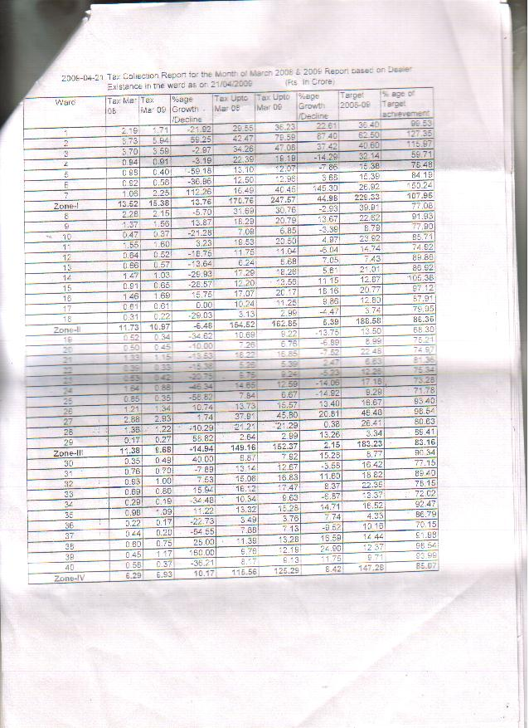
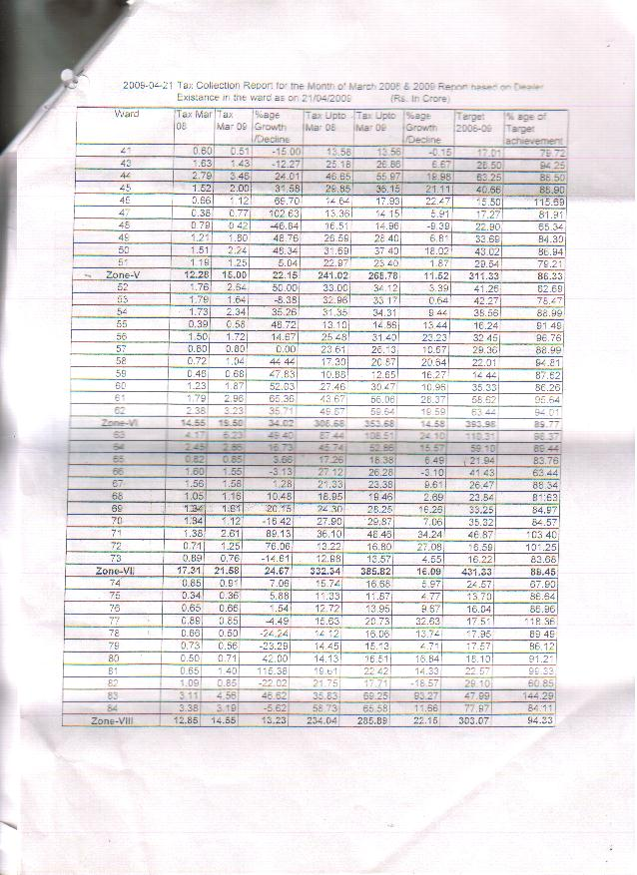
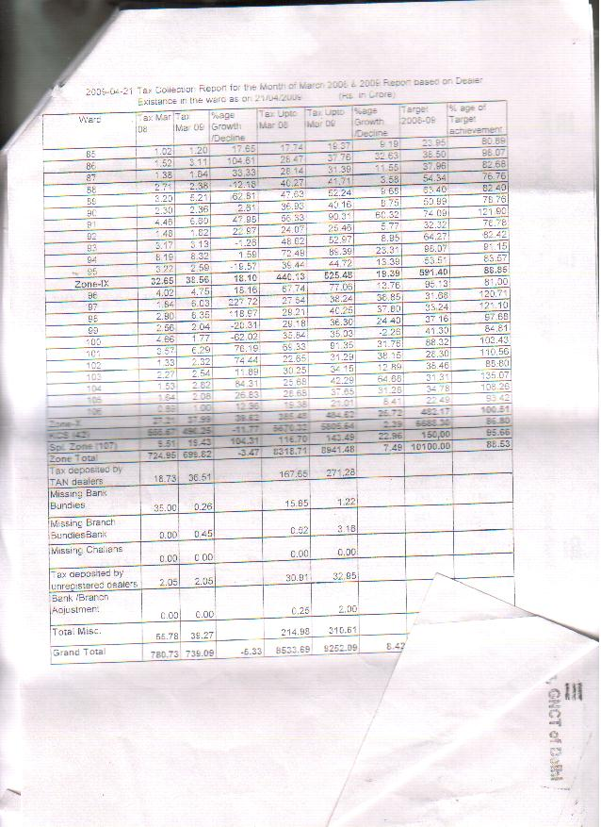
Pages 2-4 of reply given by Mr. D. P. Arora, VATO (L&S)/ PIO for LEGAL CELL, Dept. of Trade & Taxes dated 31/7/09. Relevant to Chapter B.3.3 Appeals.
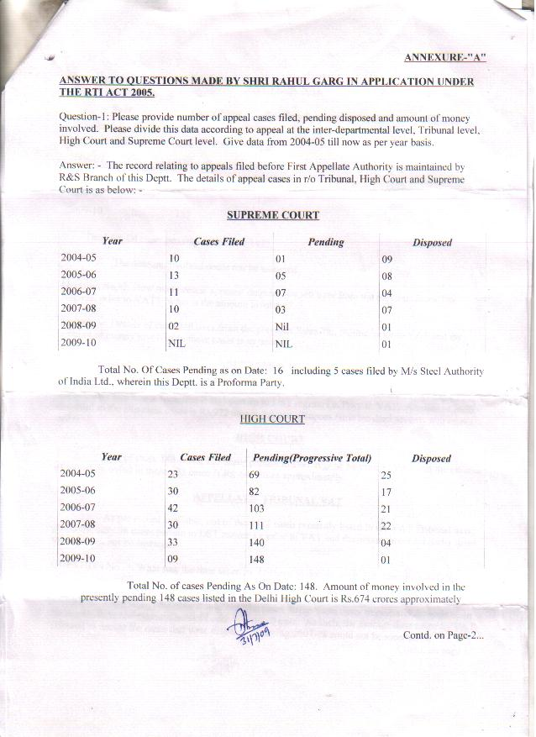
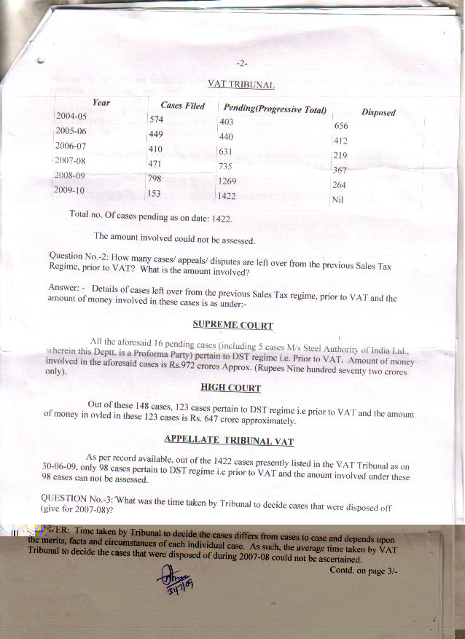
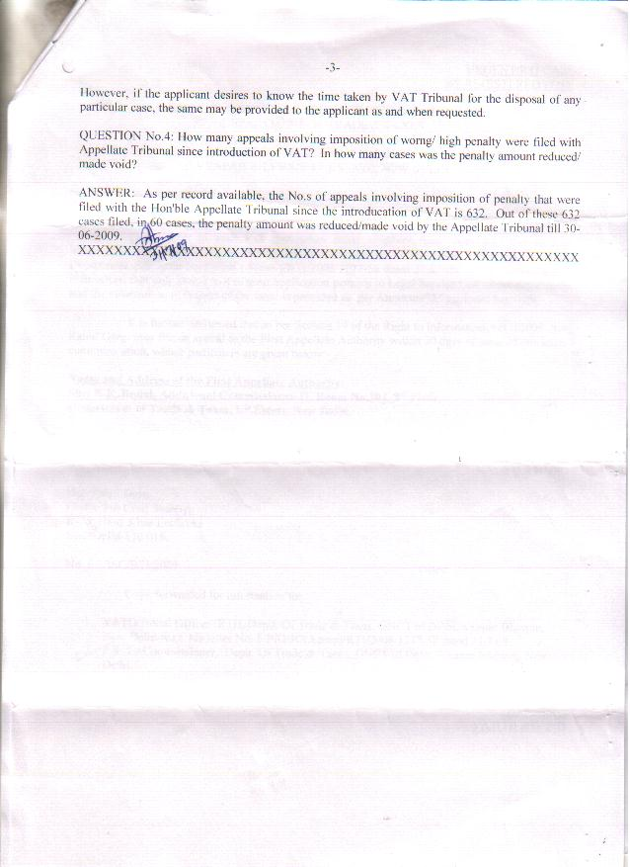

Note that high penalties have advantages too, and should not be lowered at complete discretion of VATO. See ‘Penalties, Scrutiny and Appeals’ chapter for complete discussion on this.
CAG report, 2007-08
Presentation on www.tinxsys.com
Chanchal Kumar Sharma, 2005, as quoted in OECD, 2008, 112-13
Budget Estimate from Annual Financial Statement
This same fear can be seen in state administrations during their current deliberations with the Central government over GST policy.
p44, Economic Survey of Delhi 2008-09
Note- not referring to the Retail Sales Tax in USA and Canada where exemption certificates are taken from each trader in chain until final buyer instead of an invoice system. Compared to that system, the input- credit deduction method with invoices is better for administration because it has a better self-enforcing mechanism which is appropriate in developing countries with lower book-keeping quality.
Above the Joint Secretary is the Addnl. Secretary and further the Principal Secretary, who reports to the Finance Minister.
Citizen’s Charter listing of Officers. Includes EDP manager.
There may be overlap b/w row 2 and 3.
The Hindu: Business Line. A dedicated cadre for VAT Department sought. New Delhi, October 04, 2005
Date of RTI Application- 13/07/2009.
Still, the miscellaneous collections of the department are quite high, at Rs. 310.51 crores for 2008-09.
Zones 6, 7 & 9 are almost 90%. *-highest/ lowest in group.
Project on VAT in Maharashtra - Available online at http://pakistanmba.jimdo.com-
http://finance.indiamart.com/taxation/disadvantages_of_vat.html; project on Value-Added Tax in Maharashtra available on http://pakistanmba.jimdo.com/final-project-thesis-3/
Registration with the department is still needed for dealers under composition scheme.
Citizen Charter
Detailed Demand for grants from 2005-06 till now. It was Rs. 2crore in 2005-06, and Rs. 3 crore thereafter.
DelhiExpress. Traders flood VAT helpline with questions by Shubhajit Roy. New Delhi, April 7, 2005
Note- The Key Dealers Unit has a good filing system with computerized acknowledgment. As the IT infrastructure is updated, this good work should be replicated in other Wards as well.
The Hindu: Business Line. A dedicated cadre for VAT Department sought. New Delhi, October 04, 2005
Apart from KDU Ward, which looks after large dealers.
It is supposed to be completed in the next 3-6 months.
These applications are also simply known as DVAT software system.
For a trader, he doesn’t change the product much so the tax rate for input and output will be the same.
p8, ASSOCHAM report, 2009
ASSOCHAM Report
Hindustan Times Mint. Monitoring of inter-state supplies by Satya Poddar. New Delhi, June 22, 2009
Input tax credit under within-state VAT can be set-off against a dealer’s CST liability.
Satya Poddar, 2009
Ibid.
Congress manifesto 2009

